**DRIVER ALERTNESS DETECTION**

## A PROJECT REPORT

***Submitted by,***

**RAKESH H BHAT – 20201CSE0650**

**HEMANTH ARUN BM - 20201CSE0635**

**GOWTHAM TC - 20201CSE0636**

**CHANNAKESHAVA T - 20201CSE0653**

**D CHINTHAN - 20201CSE0642**

### *Under the guidance of,*

**Dr. Jothish C**

***in partial fulfillment for the award of the degree of***

**BACHELOR OF TECHNOLOGY**

**IN**

**COMPUTER SCIENCE AND ENGINEERING**

**At**



**PRESIDENCY UNIVERSITY**

**BENGALURU**

**JANUARY 2024**

**PRESIDENCY UNIVERSITY**

**SCHOOL OF COMPUTER SCIENCE AND ENGINEERING**

**CERTIFICATE**

This is to certify that the Project report **“DRIVER ALERTNESS DETECTION”** being submitted by “**RAKESH H BHAT, HEMANTH ARUN BM, GOWTHAM TC, CHANNAKESHAVA T, D CHINTHAN**” bearing roll number(s) “**20201CSE0650, 20201CSE0635, 20201CSE0636, 20201CSE0653, 20201CSE0642**” in partial fulfilment of requirement for the award of degree of Bachelor of Technology in Computer Science and Engineering is a bonafide work carried out under my supervision.

|  |  |
| --- | --- |
| **Dr. JOTHISH C**  Selection Grade  School of CSE&IS  Presidency University | **Dr. PALLAVI R**  Associate Professor & HoD  School of CSE&IS  Presidency University |

|  |  |  |
| --- | --- | --- |
| **Dr. C. KALAIARASAN**  Associate Dean  School of CSE&IS  Presidency University | **Dr. L. SHAKKEERA**  Associate Dean  School of CSE&IS  Presidency University | **Dr. SAMEERUDDIN KHAN** Dean  School of CSE&IS  Presidency University |

**PRESIDENCY UNIVERSITY**

**SCHOOL OF COMPUTER SCIENCE AND ENGINEERING**

**DECLARATION**

We hereby declare that the work, which is being presented in the project report entitled “**DRIVER ALERTNESS DETECTION”** in partial fulfilment for the award of Degree of **Bachelor of Technology** in **Computer Science and Engineering**, is a record of our own investigations carried under the guidance of **Dr. Jothish C, Selection Grade,** **School of Computer Science Engineering , Presidency University, Bengaluru.**

We have not submitted the matter presented in this report anywhere for the award of any other Degree.

|  |  |  |  |  |  |  |  |  |  |  |  |  |  |  |  |  |  |  |  |
| --- | --- | --- | --- | --- | --- | --- | --- | --- | --- | --- | --- | --- | --- | --- | --- | --- | --- | --- | --- |
| |  |  |  | | --- | --- | --- | | Name | Roll No | Signature | | Rakesh H Bhat | 20201CSE0650 |  | | Hemanth Arun BM | 20201CSE0635 |  | | Gowtham TC | 20201CSE0636 |  | | Channakeshava T | 20201CSE0653 |  | | D Chinthan | 20201CSE0642 |  | |  |

**ABSTRACT**

The Driver Alertness System outlined in this project is a sophisticated integration of various sensors and modules, utilizing Python for real-time monitoring and decision-making. This system aims to significantly enhance road safety by addressing critical aspects of driver alertness and potential hazards. It combines advanced computer vision techniques for sleep and yawn detection, an alcohol sensor for detecting alcohol consumption, and crash detection. The comprehensive approach involves audible alarms, LCD screen notifications, and engine shutdown measures to ensure a swift and effective response to potential threats. The system's sleep and yawn detection feature employ state-of-the-art computer vision algorithms utilizing OpenCV and Dlib libraries in Python. By continuously analyzing facial expressions and movements, the system can accurately identify signs of drowsiness or yawning in the driver. The activation of audible alarms, display of relevant messages on the LCD screen, and automatic engine shutdown collectively contribute to the prevention of accidents caused by driver fatigue. An integral part of the system is an alcohol sensor designed to monitor the driver's breath for signs of alcohol consumption. This sensor utilizes established principles of alcohol detection to provide precise readings. In the event of alcohol detection, the system responds with immediate audible alarms, LCD screen notifications, and proactive measures, such as disabling the engine, to ensure that the vehicle is not operated under the influence. Python algorithms continuously analyze real-time sensor data, allowing the system to promptly identify critical events. In response to crash detection, the system sends immediate alerts to emergency contacts, authorities and designated individuals. Simultaneously, audible alarms are activated, pertinent information is displayed on the LCD screen, and the engine is automatically shut down to mitigate further risks. The seamless integration of all components ensures efficient communication between sensors and actuators. Python scripts manage the interactions between various modules, orchestrating a swift and effective response to potential threats to driver safety, ultimately fostering a safer and more secure road environment for all road users.

**ACKNOWLEDGEMENT**

First of all, we indebted to the **GOD ALMIGHTY** for giving me an opportunity to excel in our efforts to complete this project on time.

We express our sincere thanks to our respected dean **Dr. Md. Sameeruddin Khan**, School of Computer Science and Engineering & Information Science, Presidency University for getting us permission to undergo the project.

We record our heartfelt gratitude to our beloved Associate Deans **Dr. Kalaiarasan C and Dr. Shakkeera L,** School of Computer Science and Engineering & Information Science, Presidency University and Dr. “Pallavi R”, Head of the Department, School of Computer Science Engineering & Information Science, Presidency University for rendering timely help for the successful completion of this project.

We are greatly indebted to our guide **Dr. Jothish C, Selection Grade,** School of Computer Science and Engineering & Information Science, Presidency University for his inspirational guidance, and valuable suggestions and for providing us a chance to express our technical capabilities in every respect for the completion of the project work.

We would like to convey our gratitude and heartfelt thanks to the University Project-II Coordinators **Dr. Sanjeev P Kaulgud, Dr. Mrutyunjaya MS** and also the department Project Coordinators “Mr. Zia Ur Rahman and Mr. Peniel John Whistely”.

We thank our family and friends for the strong support and inspiration they have provided us in bringing out this project.

**RAKESH H BHAT**

**HEMANTH ARUN BM**

**GOWTHAM TC**

**CHANNAKESHAVA T**

**D CHINTHAN**

**LIST OF TABLES**

|  |  |  |  |
| --- | --- | --- | --- |
| **Sl. No.** | **Table Name** | **Table Caption** | **Page No.** |
| 1  2 | Table 6.5.4  Table 7.1 | Buzzer  Gantt Chart | 24  44 |

**LIST OF FIGURES**

|  |  |  |  |
| --- | --- | --- | --- |
| **Sl. No.** | **Figure Name** | **Caption** | **Page No.** |
| 1  2  3  4  5  6  7  8  9  10  11  12  13  14  15  16  17 | Fig 1.1  Fig 1.2  Fig 6.5.1  Fig 6.5.2  Fig 6.5.3  Fig 6.5.5  Fig 6.5.6  Fig 6.5.7  Fig 6.5.8  Fig 6.5.9  Fig 6.5.10  Fig 6.5.11  Fig 6.5.12  Fig 6.5.13  Fig 6.7.1  Fig 6.7.2  Appendix B | Visions of Iot  Applications of Iot  Architecture  Arduino  Buzzer  DC Motor  Qt + OpenCV  Structure of OpenCV  LCD Display  Node MCU  Gas Sensor  ADXL345  Relay  Power Supply Module  USB Cable  UART Cable  Screenshots | 2  4  20  21  24  25  26  27  30  32  33  35  36  37  40  41  55 |

**TABLE OF CONTENTS**

|  |  |  |
| --- | --- | --- |
| CHAPTER NO. | TITLE | PAGE NO. |
|  | **ABSTRACT** | viii |
|  | **ACKNOWLEDGMENT** | viii |
|  | **INTRODUCTION** | **1** |
|  | 1.1 Overview of Internet of Things | 1 |
|  | 1.2 Applications of IoT | 3 |
|  | 1.3 Introduction to Loss of Attention in  Automotive Drivers | 5 |
|  | 1.4 Problem Statement | 6 |
|  | 1.5 Purpose  1.6 Scope | 6  7 |
| 2 | **LITERATURE REVIEW** | **9** |
| 3 | **RESEARCH GAPS OF EXISTING METHODS** | **12** |
| 4 | **PROPOSED METHODOLOGY** | **13** |
| 5 | **OBJECTIVES** | **15** |
| 6 | **SYSTEM DESIGN AND IMPLEMENTATION** | **17** |
|  | 6.1 SYSTEM ANALYSIS | 17 |
|  | 6.2 SOFTWARE AND TOOLS USED | 18 |
|  | 6.3 HARDWARE REQUIREMENTS | 18 |
|  | 6.4 SYSTEM DESIGN | 18 |
|  | 6.5 SYSTEM ARCHITECTURE | 20 |
|  | 6.6 IMPLEMENTATION | 37 |
|  | 6.7 HARDWARE IMPLEMENTATION | 39 |
|  | 6.8 SOFTWARE IMPLEMENTATION | 42 |
| 7 | **TIMELINE FOR EXECUTION OF PROJECT (GANTT CHART)** | 44 |
| 8 | **OUTCOMES** | 45 |
| 9 | **RESULS AND DISCUSSIONS** | 47 |
| 10 | **CONCLUSION** | 49 |
|  | **REFERENCES** | 50 |
|  | **APPENDIX-A PSUEDOCODE** | 52 |
|  | **APPENDIX-B SCREENSHOTS** | 55 |
|  | **APPENDIX-C ENCLOSURES** | 63 |
|  |  |  |

**CHAPTER-1**

**INTRODUCTION**

**1.1 OVERVIEW OF INTERNET OF THINGS**

The Internet of Things (IoT) comprises a worldwide foundation that works with cutting edge administrations by interfacing physical and virtual elements through developing data and correspondence innovations. It includes the between systems administration of different articles, including actual gadgets, vehicles, structures, and that's only the tip of the iceberg, all implanted with hardware, programming, sensors, actuators, and organization availability. This interconnected organization empowers these substances, frequently alluded to as "associated gadgets" or "brilliant gadgets," to gather and trade information consistently. The center idea of IoT rotates around ordinary actual items being associated with the web, permitting them to recognize themselves to different gadgets. RFID, sensor innovations, remote correspondence, and QR codes are key components related with IoT, working with correspondence and information trade. It frames an arrangement of interrelated registering gadgets, mechanical and computerized machines, articles, creatures, or individuals, each outfitted with remarkable identifiers and the capacity to move information over an organization without direct human intercession. IoT stretches out past machine-to-machine interchanges, covering assorted conventions, spaces, and applications. The network goes from vehicles, kitchen apparatuses, to heart screens, addressing the mix of different gadgets into the web. The essential objective is to make a "brilliant" climate where gadgets team up with one another and focal frameworks, improving proficiency and navigation. The effect of IoT traverses numerous areas, including medication, power, quality treatments, horticulture, brilliant urban communities, and shrewd homes. As innovation keeps on progressing, IoT is expected to reform regular routines by offering progressed benefits and significantly altering the manner in which individuals communicate with their surroundings. Wearable gadgets, shrewd sensors, and other IoT innovations add to the production of versatile and interconnected frameworks. While introducing potential open doors for advancement, IoT additionally raises concerns connected with security, protection, and normalization, which should be addressed as the environment keeps on developing. In general, IoT addresses a groundbreaking power forming the fate of innovation and human communications. The Internet of Things (IoT) refers to the interconnected network of physical devices, vehicles, appliances, and other objects embedded with sensors, software, and network connectivity, enabling them to collect and exchange data. The fundamental concept behind IoT is to create a "smart" environment where devices can communicate and collaborate with each other, as well as with central systems, to enhance efficiency, convenience, and decision-making. Internet of Things (IoT) is the networking of physical objects that contain electronics embedded within their architecture in order to communicate and sense interactions amongst each other or with respect to the external environment. In the upcoming years, IoT-based technology will offer advanced levels of services and practically change the way people lead their daily lives. Advancements in medicine, power, gene therapies, agriculture, smart cities, and smart homes are just a few of the categorical examples where IoT is strongly established. IOT is a system of interrelated things, computing devices, mechanical and digital machines, objects, animals, or people that are provided with unique identifiers. And the ability to transfer the data over a network requiring human-to-human or human-to-computer interaction.

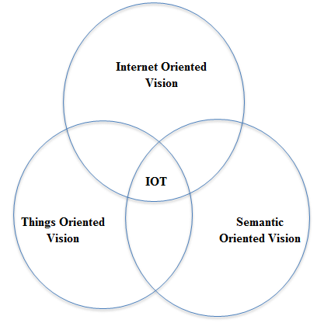

Fig 1.1 Visions of IoT

**1.2 APPLICATIONS OF IOT**

The Internet of Things (IoT) has quickly extended its impact across different businesses, offering creative answers for upgrade effectiveness, efficiency, and generally speaking personal satisfaction. The uses of IoT are assorted, influencing areas going from medical care to agribusiness, savvy urban communities, modern cycles, and customer hardware.

* Medical services: IoT has changed medical care with applications like far off understanding checking, savvy clinical gadgets, and wearable wellbeing trackers. These gadgets gather continuous wellbeing information, permitting medical services suppliers to offer customized and opportune mediations, lessening the requirement for successive clinic visits.
* Savvy Urban areas: IoT assumes a significant part in making brilliant urban communities by enhancing metropolitan framework. Shrewd traffic the executives, squander the board, energy-effective lighting, and natural observing are a few applications that upgrade city day to day environments and maintainability.
* Modern IoT: In the modern area, IoT applications incorporate prescient upkeep, resource following, and cycle improvement. Sensors on machines gather information, empowering continuous checking, lessening margin time, and improving generally functional productivity.
* Horticulture: Accuracy cultivating is altered by IoT, with applications like soil observing, crop wellbeing following, and robotized water system. These advancements empower ranchers to pursue information driven choices, streamline asset utilization, and further develop crop yields.
* Home Mechanization: Brilliant homes influence IoT for expanded robotization and energy effectiveness. Associated gadgets like savvy indoor regulators, lights, and security frameworks can be somewhat controlled and checked through versatile applications, offering comfort and security.
* Retail: IoT improves the retail insight through applications like stock administration, shrewd retires, and customized client associations. Retailers can upgrade supply chains, lessen stockouts, and give customized advancements in view of client conduct.
* Transportation: Associated vehicles and brilliant transportation frameworks are key IoT applications. These incorporate continuous traffic observing, prescient support for vehicles, and shrewd leaving arrangements, adding to more secure and more productive transportation organizations.
* Store network: The executives: IoT further develops production network perceivability by following merchandise progressively. This incorporates observing the area, condition, and status of items during travel, empowering more proficient coordinated factors activities.

As IoT keeps on developing, its applications are probably going to grow further, tending to new difficulties and giving imaginative arrangements across different areas. The capacity of IoT to interface the physical and computerized universes offers extraordinary open doors for proficiency, mechanization, and further developed dynamic in many businesses.

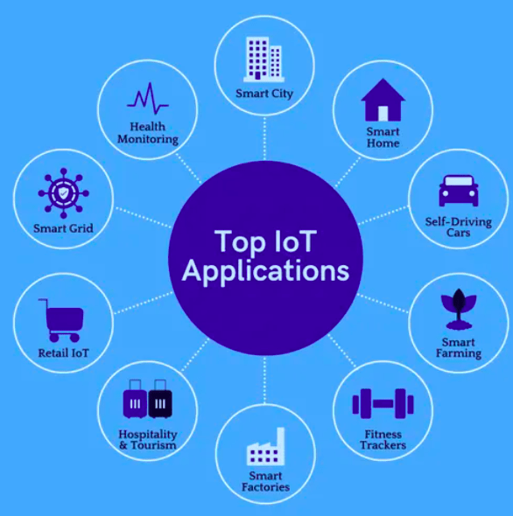

Fig 1.2 Applications of IoT

**1.3 INTRODUCTION TO LOSS OF ATTENTION IN AUTOMOTIVE DRIVERS**

The issue of deficiency of consideration in car drivers has turned into a developing worry as present day culture progressively depends on vehicles for transportation. Consideration assumes a urgent part in guaranteeing safe driving, and when it disappears, the gamble of mishaps fundamentally rises. This peculiarity is normally alluded to as driver carelessness or occupied driving, including different variables that redirect a driver's consideration from the essential errand of working a vehicle.

In the contemporary time, mechanical headways have presented a heap of interruptions inside the driving climate. The utilization of cell phones, route frameworks, and in-vehicle theater setups can prompt mental, visual, and manual interruptions. Moreover, outside elements like side of the road notices, bulletins, and even discussions with travelers add to the complicated scene of potential consideration slips.

One huge supporter of consideration misfortune is the utilization of cell phones while driving. The charm of instant messages, calls, and virtual entertainment warnings can lead drivers to take their eyes off the street, hands off the controlling wheel, and concentrate away from the basic errand of driving. The results of such interruptions are significant, with a disturbing expansion in mishaps, wounds, and fatalities owing to heedless driving.

Weariness and sluggishness likewise assume a significant part in the deficiency of consideration among drivers. Extended periods in the driver's seat, repetitive street conditions, and deficient rest can debilitate a driver's capacity to remain on track, prompting deferred responses and unfortunate navigation. The outcomes of sleepy driving can be all around as extreme as those subsequent from different types of interruption.

Resolving the issue of consideration misfortune in car drivers is basic for upgrading street security. Understanding the variables adding to driver heedlessness and executing measures to moderate these dangers, for example, public mindfulness missions, regulation, and mechanical intercessions, are basic strides toward encouraging a more secure driving climate. As society keeps on embracing mechanical headways, tracking down a harmony between the advantages of network and the basic of keeping up with driver consideration becomes foremost in guaranteeing the prosperity of all street clients.

**1.4 PROBLEM STATEMENT**

The rising pervasiveness of street mishaps credited to driver sluggishness has arisen as a basic wellbeing concern. Tired driving represents a huge gamble to street clients, prompting a higher probability of mishaps, wounds, and fatalities. Notwithstanding mindfulness crusades and administrative measures, the test of recognizing and forestalling driver sluggishness continues, requesting dire consideration. The essential issue comes from the trouble in dependably distinguishing indications of tiredness continuously. Conventional techniques, like self-detailing or dependence on perceptible ways of behaving, are frequently emotional and inclined to blunders. Also, the reconciliation of arising innovations into vehicles, for example, high level infotainment frameworks and route apparatuses, further adds to mental interruptions, worsening the tiredness issue. An absence of normalized and generally embraced frameworks for driver sluggishness identification hampers the execution of successful preventive measures. There is a squeezing need for powerful, non-meddling, and generally relevant arrangements that can precisely evaluate a driver's degree of sharpness in different driving circumstances. Resolving this issue requires interdisciplinary cooperation between scientists, designers, and policymakers to create and carry out dependable tiredness location innovations. These arrangements ought to be consistently coordinated into vehicles, giving ongoing input and mediations to relieve the dangers related with sleepy driving, eventually cultivating a more secure street climate for all.

**1.5 PURPOSE**

The reason for driver drowsiness discovery is in a general sense established in the overall objective of further developing street wellbeing and moderating the extreme outcomes related with mishaps brought about by sleepy driving. The acknowledgment of the unfavorable effect of driver exhaustion on street security has prodded the turn of events and execution of advances pointed toward identifying and forestalling drowsiness progressively. One main role is to lessen the disturbing paces of mishaps ascribed to sleepy driving. Weakness essentially weakens a driver's mental capabilities, response times, and in general capacity to securely work a vehicle. By recognizing indications of tiredness, for example, eyelid conclusion or inconsistent driving way of behaving, location frameworks can intercede speedily, alarming the driver or starting robotized wellbeing measures. This convenient intercession is vital for forestalling mishaps and limiting the seriousness of likely crashes. Upgrading by and large street security is another key reason. Sleepiness location innovations add to establishing a more secure driving climate by tending to one of the significant gamble factors on the streets. Proactive measures, for example, cautions or mediations, assist with guaranteeing that drivers are ready and centered, lessening the probability of mishaps brought about by weakened consideration and deferred responses. Besides, the execution of drowsiness discovery effectively promotes dependable driving way of behaving. By bringing issues to light about the risks of driving while exhausted and giving constant criticism to drivers, these frameworks urge people to focus on their prosperity and that of others out and about. This lines up with more extensive endeavors to develop a culture of wellbeing and cognizance among drivers. Also, the arrangement of tiredness location advancements lines up with administrative and industry norms pointed toward further developing vehicle wellbeing. Numerous nations and locales have perceived the significance of tending to sluggish passing through regulation and rules. In this manner, coordinating sleepiness recognition frameworks into vehicles adds to satisfying these wellbeing guidelines and satisfying administrative necessities. In rundown, the reason for driver sleepiness identification is diverse. It expects to lessen mishaps, improve street wellbeing, advance capable driving way of behaving, and line up with administrative norms. By resolving the unavoidable issue of sleepy driving, these innovations assume an essential part in protecting lives and making a more secure and safer transportation biological system.

**1.6 SCOPE**

The extent of driver drowsiness discovery reaches out across different areas, mirroring its importance in improving street wellbeing and forestalling mishaps brought about by debilitated driver sharpness. As innovation keeps on propelling, the extent of sleepiness recognition includes different applications, research roads and cultural ramifications.

* Car Industry Combination: Tiredness identification innovations significantly affect the auto business. The incorporation of these frameworks into vehicles, going from standard cars to business armadas, adds to a more secure driving experience. As the car area progressively embraces independent driving innovations, tiredness identification turns into a basic part for guaranteeing the security of the two drivers and travelers.
* Interdisciplinary Exploration: The degree reaches out to interdisciplinary examination including fields like PC vision, man-made reasoning, human-PC cooperation, and brain research. Specialists investigate creative procedures, sensor innovations, and calculations to upgrade the precision and effectiveness of drowsiness identification frameworks.
* Wearable and IoT Gadgets: The extent of sleepiness location reaches out to wearable gadgets and the Web of Things (IoT). Wearable contraptions outfitted with sensors can screen physiological signs characteristic of tiredness, giving constant input to clients. Moreover, IoT-based applications can interface with vehicle frameworks to communicate alarms or start security measures when tiredness is distinguished.
* Administrative Consistence: The degree incorporates adherence to and forming of administrative norms connected with street security. Legislatures and administrative bodies perceive the significance of relieving the dangers related with sluggish driving.
* Public Mindfulness and Training: Tiredness discovery advancements play a part in cultivating public mindfulness and schooling. Instructive missions can feature the risks of driving while exhausted and stress the advantages of using tiredness discovery frameworks.
* Protection and Hazard The executives: The degree reaches out to protection and chance administration rehearses. Back up plans might consider boosting or requiring the establishment of sleepiness recognition frameworks in vehicles to alleviate the gamble of mishaps and related claims. This coordination lines up with more extensive industry endeavors to improve risk evaluation and the executives.

All in all, the extent of driver drowsiness recognition is complete, enveloping mechanical progressions, interdisciplinary examination, administrative consistence, public mindfulness, protection rehearses, and its combination into worldwide driving settings. As a basic component chasing street wellbeing, the proceeded with improvement and execution of sleepiness identification innovations hold huge potential for having a beneficial outcome on worldwide transportation frameworks.

**CHAPTER-2**

**LITERATURE SURVEY**

"A Comprehensive Evaluation of Systems for Detecting Driver Alertness” [1]

This research examines a range of sensor technologies, such as electroencephalography (EEG), eye-tracking mechanisms, and analysis of steering behavior. These methods allow for the real-time monitoring of driver alertness without being obtrusive. Nevertheless, it should be noted that EEG sensors may cause discomfort to drivers.

"Advancements in Sleep Detection Techniques for Monitoring Driver Alertness" [2]

To effectively track sleep patterns without invading privacy, wearable sleep tracking devices and cameras installed within vehicles are utilized. This non-invasive approach provides an avenue for monitoring sleep patterns discreetly. however, its accuracy in detecting transient episodes of microsleep may be limited.

"A Critical Analysis on Alcohol Detection Mechanisms Integrated into Driver Alertness Systems" [3]

In-vehicle alcohol sensors and breathalyzers are integrated to promptly identify potential impairment caused by alcohol consumption. Employing this method facilitates swift identification of risks associated with driving under the influence. Nonetheless, challenges arise due to reliance on the driver's willingness to cooperate with these detection systems."

"Utilizing Machine Learning Techniques for Driver Alertness Systems" [4]

Incorporating data-driven methodologies, this research employs machine learning algorithms to detect and monitor alertness levels with adaptability and personalization. This sophisticated approach enables real-time monitoring of individual alertness patterns. However, successful implementation necessitates access to extensive datasets for training purposes.

"Incorporating Crash Detection in Driver Alertness Systems" [5]

To effectively address the severity of accidents and enable prompt response, this study integrates accelerometer technology and vehicle telematics into driver alertness systems. Such integration significantly enhances the overall capabilities of these systems. Nonetheless, a critical challenge lies in accurately differentiating between intentional abrupt movements by drivers from unintentional ones.

"A Comparative Analysis of Driver Alertness Systems in Commercial Fleets" [6]

By examining the deployment of GPS tracking within commercial fleets, this analysis explores its impact on enhancing safety measures as well as productivity rates across the fleet operations. This innovative approach holds immense potential for bolstering safety standards while simultaneously improving productivity levels among commercial fleets. Nevertheless, it is worth noting that challenges related to initial implementation costs may arise alongside potential resistance from some drivers during adoption phases.

"Exploring the Use of Facial Recognition for Real-time Driver Fatigue Identification" [7]

Investigating the feasibility and accuracy of facial recognition technology in identifying early signs of driver fatigue by analyzing facial expressions and eye movements. This approach aims to enhance alertness detection without requiring additional sensors or intrusive measures.

"Impact of Sleep Quality on Driver Alertness: A Wearable Technology Perspective" [8]

Analyzing the correlation between sleep quality metrics collected from wearable devices, such as smartwatches or sleep-tracking wearables, and the driver's alertness level during daytime driving. This research aims to develop insights into how pre-driving sleep patterns affect on-road alertness.

"Smart Clothing for Driver Alertness Monitoring: Integrating Sensors into Apparel" [9]

Exploring the integration of sensors into smart clothing, such as shirts or hats, to monitor physiological signals indicative of driver alertness. This approach provides a convenient and non-intrusive means of continuous monitoring during driving.

"Assessment of Cognitive Workload in Driver Alertness Systems" [10]

Investigating methods to measure cognitive workload through neuroscientific approaches, eye-tracking, or other cognitive load metrics. Understanding the cognitive demands placed on drivers can contribute to more accurate alertness detection and the development of adaptive systems.

"Effectiveness of Virtual Reality Simulations in Driver Alertness Training" [11]

Examining the impact of virtual reality simulations in training drivers to recognize and respond to alertness-related challenges. Virtual scenarios can provide a controlled environment for practicing alertness-enhancing techniques and assessing the effectiveness of training interventions.

"Validation of Driver Alertness Algorithms: A Large-scale Field Study" [12]

Conducting a large-scale field study to validate the accuracy and reliability of various driver alertness algorithms in real-world driving conditions. This research aims to bridge the gap between controlled laboratory experiments and the complexities of actual driving scenarios.

"Investigating the Role of Biometric Feedback in Real-time Alertness Enhancement" [13]

Exploring the use of biometric feedback, such as heart rate variability or galvanic skin response, to provide real-time alerts and interventions aimed at enhancing driver alertness. This research aims to leverage physiological signals for timely interventions without causing distraction.

"Human-AI Collaboration in Driver Alertness Systems" [14]

Studying the collaborative interaction between human drivers and artificial intelligence systems in monitoring and enhancing driver alertness. This research explores how AI can complement human decision-making and response mechanisms to create more effective alertness systems.

**CHAPTER-3**

**RESEARCH GAPS OF EXISTING METHODS**

A prominent issue in ebb and flow driving situations is the commonness of attentional weakness, influencing a driver's response time. Driving while tired stands apart as a significant supporter of street mishaps, introducing a higher accident risk contrasted with driving in an alarm state. Tending to this worry, an assistive framework has been created to screen a driver's watchfulness level and issue cautions in the event of tiredness. The current framework centers around distinguishing sluggishness through estimations of yawning and head development. This includes continuous cycles, for example, face identification and following, mouth shape examination, yawning location in view of changes in mouth shape region and head development following.

Already, sensor-worked gadgets like goggles were used for tiredness discovery utilizing MATLAB, with manual keeps an eye on the driver's circumstances prior to starting excursions. Sadly, these techniques needed ongoing notices about the driver's sluggishness, highlighting the irreversibility of life once lost in a mishap. Cutting edge innovations present a beam of trust in decreasing such mishaps, especially those connected with rest, which will generally be more serious because of higher paces included and the crippling of drivers to make shifty moves.

Different elements add to mishaps, including the inability to change the splendor level of lights while experiencing vehicles from the other way, mishaps brought about by abrupt intruders on one or the other side of the vehicle, and rest related mishaps where drivers run off the street or crash into different vehicles. Z. Xiaoronget's model for programmed liquor identification, in view of a MQ-6 liquor sensor and IoT, gives an extra layer of security. The model includes fitting liquor sensors, shows, and GPRS modules in vehicles to identify liquor content, consequently setting off cautions and area sharing assuming that liquor levels outperform foreordained limits.

**CHAPTER-4**

**PROPOSED METHODOLOGY**

The imagined framework is developed on the underpinning of the OpenCV picture handling library, with QT filling in as the manager. The essential accentuation is put on quick sleepiness identification and smoothed out information handling. The framework utilizes a Logitech camera to accomplish continuous location of the driver's eye state, recognizing open and shut eyes. Prominently, drivers stay detached to outer gadgets, and the probability of failing is limited. An inventive technique for recognizing driver tiredness/lethargy is carried out on an Arduino microcontroller board, consolidating readings from different sensors. This incorporates the use of a MQ-6 liquor gas sensor to distinguish liquor utilization, combined with a transfer circuit to keep the driver from working the vehicle on the off chance that liquor is recognized. Alarms are set off when the driver has polished off liquor or displays regular head gestures or shut eyes.

The philosophy coordinates a Haar Classifier, an AI approach for visual item location at first planned by Viola and Jones. While initially planned for facial milestone and shape expectation, it is adjusted for identifying hypo-carefulness levels in the proposed idea. Consistent recording of the driver's face through a camera works with the recognizable proof of shut eye signals characteristic of sluggishness. The framework deciphers a raised eye flicker recurrence as an indication of exhaustion, and miniature rests enduring 3 to 4 seconds act as urgent markers. The shut eye signal location is carried out utilizing OpenCV, giving cautions to the driver through a bell to expeditiously address exhaustion.

To follow the area of a possibly inebriated driver for distant correspondence, a satellite-based GPS recipient module with a radio wire is integrated. Using regular citizen GPS flags, the GPS module gives an area exactness of 30-50 meters in something like 5 minutes or less, the time expected to lock onto a satellite in a moving vehicle. The dynamic tracker intends to outfit ongoing area data of a vehicle with an inebriated driver.

Moreover, the task proposes a framework for identifying hand-held wireless utilization during driving, utilizing a ring pointer for movement location. The framework's result choices incorporate admonitions to pull together the driver solely on the vehicle and the street, warnings for transport organizations, or initiation of a ringer. Liquor sensors are likewise incorporated, detecting liquor utilization up to preset rate edges. On the off chance that the driver outperforms the characterized liquor limit, the signal enacts as an advance notice, and the start framework remains non-functional.

One more part of the undertaking includes estimating and controlling eye flickers utilizing IR sensors. The IR transmitter produces infrared beams into the eye, with the IR beneficiary catching reflected beams. In the event that the eyes are shut, the IR beneficiary result is high; in any case, it is low. This data is handled by a rationale circuit to set off a caution, forestalling mishaps made by obviousness due eye flickers. An eye squint sensor, fixed in the vehicle, recognizes obviousness and signs an alert, adding to upgraded security measures.

**CHAPTER-5**

**OBJECTIVES**

1.Early Detection of Fatigue:

- Implement computer vision algorithms to monitor facial expressions in real-time.

- Identify signs of drowsiness and yawning as early indicators of driver fatigue.

2. Prevention of Drunk Driving:

- Integrate an alcohol sensor for continuous monitoring of the driver's breath.

- Detect and deter alcohol consumption by initiating immediate responses, such as audible alarms, LCD notifications and engine shutdown.

3. Timely Response to Crashes:

- Implement immediate response mechanisms, including alerting emergency contacts, authorities and designated individuals, along with activating alarms, LCD notifications and automatic engine shutdown.

4. Seamless System Integration:

- Develop Python scripts to facilitate efficient communication between various sensors and actuators.

- Ensure a cohesive integration of sleep and yawn detection, alcohol monitoring and crash detection components.

5. User-Friendly Interface:

- Design a user-friendly interface with an LCD display for clear notifications and real-time feedback to the driver.

6. Adaptability and Modularity:

- Design the system to be adaptable to various vehicle types and driving conditions.

- Ensure modularity to facilitate easy integration with different sensors and technologies.

7. Addressing Challenges:

- Tackle challenges related to sensor calibration, sensitivity and legal compliance.

- Contribute to ongoing research and development efforts to refine the system and overcome potential obstacles.

8. Continuous Improvement:

- Foster a commitment to continuous improvement in the system's accuracy, reliability and effectiveness.

- Explore opportunities for enhancements, such as the integration of advanced machine learning models and emerging technologies like 5G.

9. Overall Road Safety Impact:

- Contribute significantly to overall road safety by preventing accidents associated with driver fatigue and impairment.

- Strive to create a safer driving environment through the successful implementation of the system's objectives.

**CHAPTER-6**

**SYSTEM DESIGN & IMPLEMENTATION**

**6.1 SYSTEM ANALYSIS**

System analysis for the proposed driver alertness detection and prevention system involves a comprehensive evaluation of its components, functionalities and potential impact. Here is a breakdown of the system analysis:

1. System Components:

* Real-time Monitoring Components:

Facial recognition and tracking system

Mouth contour detection and tracking

* Drowsiness Detection Components:

Yawning measurement

Eye state monitoring using OpenCV

Closed eye gesture detection

* Alcohol Detection Components:

MQ-6 alcohol sensor

* Location Tracking Components:

Node MCU

2. System Functionalities:

* Driver Monitoring:

Continuous real-time monitoring of facial features, mouth contour and head movement.

* Drowsiness Detection:

Yawning measurement and closed eye gesture detection to identify signs of drowsiness.

* Alcohol Detection:

MQ-6 alcohol sensor for detecting alcohol levels in the driver's breath.

* Location Tracking:

GPS module for tracking the vehicle's location in case of crash.

3. System Integration:

* Integration of facial recognition, drowsiness detection, alcohol detection and location tracking components into a cohesive system.
* Communication between the microcontroller, Node MCU module and other sensing components.
* Real-time data processing and decision-making for issuing alerts and preventing accidents.

**6.2 SOFTWARE AND TOOLS USED**

* OPERATING SYSTEM: Windows
* LIBRARY: Open CV, Dlib, Imutils, Numpy, Serial
* LANGUAGES: C and Python
* EDITOR: QT

**6.3 HARDWARE REQUIREMENTS**

* Buzzer
* PC with required libraries
* Microcontroller – ARDUINO
* 12V DC Motors – 60rpm
* IR Sensor
* Alcohol Sensor
* Camera

**6.4 SYSTEM DESIGN**

The proposed system design for driver alertness and crash detection centers around a unique approach, utilizing strategically placed vibrators within the vehicle to capture vibrational patterns indicative of potential crash events or irregular driving behavior. The system is designed to interpret variations in these vibrations and identify specific vibrational signatures associated with abrupt movements or collision scenarios. By harnessing this unconventional method, the system aims to enhance driver safety without relying on traditional speed and acceleration metrics.

The system comprises vibration sensors strategically positioned within the vehicle, along with a sophisticated algorithm for real-time data analysis. The algorithm is tasked with distinguishing between normal driving conditions and instances suggestive of potential crashes. This necessitates a comprehensive understanding of the distinct vibrational patterns associated with different driving scenarios, including sudden stops, collisions, or erratic driving behavior. The sensitivity of the vibration sensors is a critical consideration to ensure accurate data capture without generating false positives or negatives.

In addition to the vibration-based approach, the system design may incorporate complementary technologies, such as GPS modules or vehicle telematics, to provide additional context to the detected vibrations. This holistic design aims to offer a comprehensive solution for detecting driver alertness issues and potential crash events solely through the analysis of vehicular vibrations.

Continuous refinement and testing are integral components of the system design process to ensure the reliability, accuracy, and practical applicability of the proposed approach in preventing accidents caused by impaired driver alertness or unexpected collision scenarios.

**6.5 SYSTEM ARCHITECTURE**

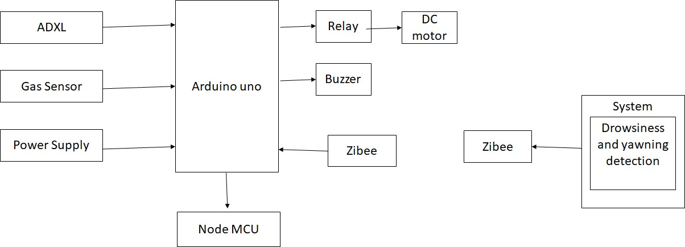

Fig 6.5.1 Architecture

**ARDUINO**

Arduino is an open-source programmable circuit board that can be integrated into a wide variety of makerspace projects both simple and complex.

This board contains a microcontroller which is able to be programmed to sense and control objects in the physical world. By responding to sensors and inputs, the Arduino is able to interact with a large array of outputs such as LEDs, motors and displays.

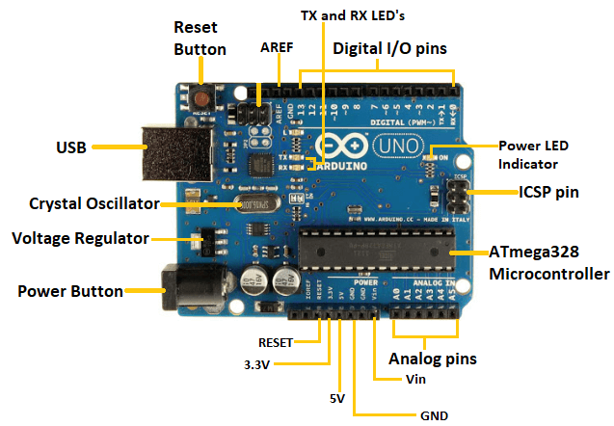

Fig 6.5.2 Arduino

Power USB: The Arduino Uno can be powered via the USB connection, drawing power from a connected computer or USB power source.

Power: An alternative power input, allowing the board to be powered by an external DC power source (typically 7-12V). The board has a built-in voltage regulator that regulates this input to 5V, which powers the board.

Voltage Regulator: The board includes a voltage regulator (typically an LM7805) that stabilizes the voltage to provide a consistent 5V supply to the microcontroller and other components.

Crystal Oscillator: The Uno uses a 16 MHz ceramic resonator (labelled 16.000H9H) to provide precise timing for the microcontroller's operations. The crystal oscillator helps Arduino in dealing with time issues. How does Arduino calculate time? The answer is, by using the crystal oscillator.

5, 17- Arduino Reset: There's a reset button (labelled RESET) on the board, allowing you to restart the program execution from the beginning.

6, 7, 8 ,9- Pins (3.3, 5, GND, Vin)

Pins (3.3V, 5V, GND, Vin):

3.3V: Supplies a 3.3V output.

5V: Supplies a 5V output.

GND: Ground pins for circuit grounding.

Vin: External power input for the Arduino board

Analog pins: The board offers 6 analog input pins, labelled A0 to A5. These pins can read analog signals from sensors and convert them to digital values for processing

Main-microcontroller: ATmega328 Microcontroller- is a single chip Microcontroller of the ATmel family. The processor code inside it is of 8-bit. It combines Memory (SRAM, EEPROM, and Flash), Analog to Digital Converter, SPI serial ports, I/O lines, registers, timer, external and internal interrupts, and oscillator.

ICSP pin: - The In-Circuit Serial Programming pin allows the user to program using the firmware of the Arduino board and it the consisting of MOSI, MISO, SCK, RESET, VCC, and GND

Power LED indicator: Indicates that the board is receiving power. If this light does not turn on, then there is something wrong with the connection.

TX and RX LEDs: These LEDs (located near pins 0 and 1) blink during serial communication. TX (transmit) blinks when data is sent, and RX (receive) blinks when data is received.

Digital I/O: The Uno has 14 digital I/O (input/output) pins, marked from 0 to 13. Among these, pins 3, 5, 6, 9, 10, and 11 support PWM (Pulse Width Modulation) output. The pins labelled can be used to generate PWM.

AREF: The Analog Reference (AREF) pin is used to feed a reference voltage to the Arduino UNO board from the external power supply

Basic Function of Arduino Technology:

* Hardware Interface: Arduino boards come with various input and output pins (analog, digital, PWM, etc.) that allow users to connect sensors, motors, LEDs, displays, and other components easily.
* Programming: Users write code in the Arduino IDE, typically using C/C++ syntax. The code can read inputs from sensors, perform computations, and control outputs.
* Interactivity: It facilitates interaction between hardware and software, enabling users to create interactive projects like robots, automated systems, IoT devices, etc.

Digital read pin reads the digital value of the given pin.

Analog read pin reads and returns the value.

Analog write pin writes the value of the pin.

Serial begins pin sets the beginning of serial communication by setting the rate of bit.

Advantages of Arduino Technology:

* Open-Source: Arduino's open-source nature encourages a large community of developers to contribute libraries, code examples, and projects, fostering continuous innovation and learning.
* User-Friendly: Its IDE is beginner-friendly, making it accessible for newcomers to programming and electronics. The boards are relatively easy to set up and use.
* Versatility: Arduino boards come in various sizes and types, catering to different project requirements. They can be adapted for a wide range of applications.
* Affordability: Arduino boards and components are relatively inexpensive compared to other development platforms, making them accessible for educational purposes and prototyping.
* Community Support: The active Arduino community provides forums, tutorials, and extensive documentation, offering support and assistance to users at different skill levels.

**BUZZER**

An active buzzer is an electronic component that generates sound when it receives an electrical signal. Unlike a passive buzzer, which requires an external signal oscillating at an audible frequency to produce sound, an active buzzer has an internal oscillator circuit that produces the necessary oscillation, hence, it's "active”.

Function of an Active Buzzer:

* Sound Generation: When an electrical signal is applied to the active buzzer, its internal oscillator circuit generates an oscillating signal at an audible frequency, causing the buzzer to produce sound.
* Simplicity in Usage: Active buzzers are relatively straightforward to use compared to passive buzzers since they don’t need an external oscillating signal. You provide power, and they're ready to make some noise!
* Applications: They find use in various applications where a simple audible alert or notification is needed, such as alarms, timers, and other signalling devices. They are often utilized in electronic projects and prototypes due to their ease of use.

Buzzer Features and Specifications:

* Rated Voltage: 6V DC
* Operating Voltage: 4-8V DC
* Frequency: ~2300 Hz
* Sound Type: Continuous Beep

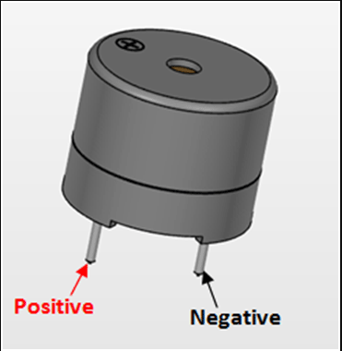

Fig 6.5.3 Buzzer

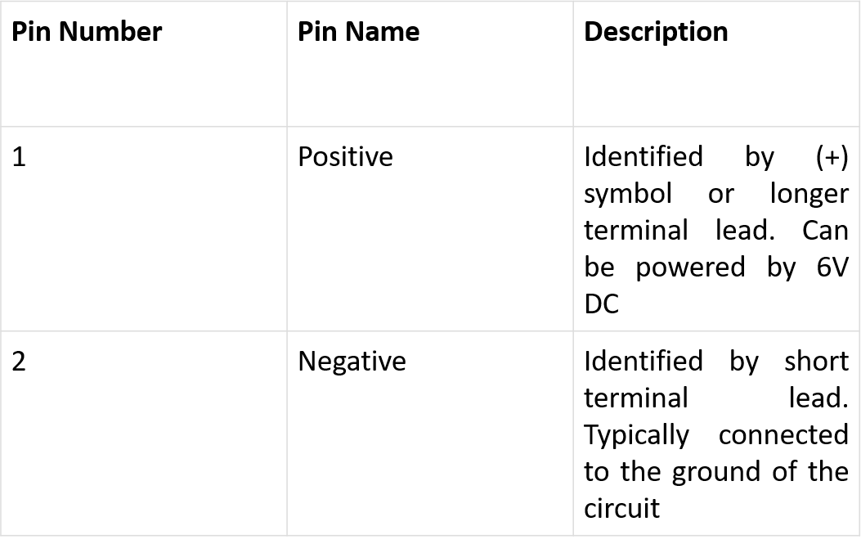

Table 6.5.4 Buzzer

**DC MOTOR**

DC motors are electrical machines that convert electrical energy into mechanical energy through the interaction of magnetic fields. They operate on direct current (DC) electricity, and their operation relies on the principles of electromagnetism.

DC motors are interfaced to Arduino using L293D Motor Driver IC. It can control both speed and spinning direction of two DC motors.



Figure 6.5.5 DC Motor

Specification:

* Operating Voltage: 12V DC
* Torque: 2 kg-cm
* Shaft Diameter: 6mm
* RPM (Revolutions per Minute): 45
* No-load current: 60 mA
* Load current: 300 MA

**OPEN CV**

OpenCV, short for Open-Source Computer Vision, stands as a comprehensive library of programming functions crafted primarily for real-time computer vision applications. Its roots trace back to Intel, originally conceived in 1999 as an initiative to bolster CPU-intensive applications like real-time ray tracing and 3D display walls.

Initially, the project flourished under Intel's stewardship, subsequently gaining support from entities such as Willow Garage and Itseez, which later became part of Intel. This collaboration and support facilitated the library's evolution into a cross-platform tool available for Windows, Linux, Android, and macOS, making it accessible to a wide developer community.

One of its prominent attributes is its flexibility across multiple programming languages, offering interfaces for C++, Python, Java, and MATLAB. This versatility allows developers to leverage their preferred language for integrating OpenCV into their projects. Furthermore, ongoing efforts involve the active development of CUDA and OpenCL interfaces, aiming to fully harness the capabilities of GPU parallel processing, which can significantly enhance computational efficiency. This library boasts an extensive arsenal of over 500 algorithms complemented by a plethora of supporting functions. These tools cater to various aspects of image processing, computer vision, and machine learning tasks.

The goals outlined for the OpenCV project can be summarized into three key objectives:

1. Advancing Vision Research with Optimized Code: The project aimed to propel vision research by offering not just open-source code but also optimized implementations of fundamental vision infrastructure.

2. Disseminating Vision Knowledge through a Common Infrastructure: OpenCV aimed to disseminate vision knowledge by establishing a shared and standardized infrastructure

3.Advancing Vision-Based Commercial Applications with Portable Performance: The project aimed to contribute to the advancement of vision-based commercial applications



Fig 6.5.6 Qt + OpenCV

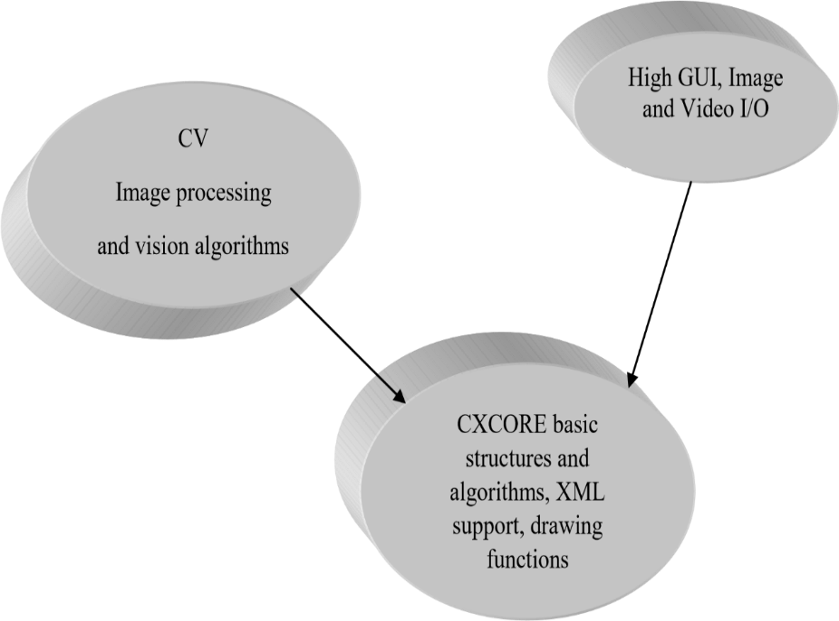

Fig 6.5.7 Structure of OpenCV

Features of Open CV:

* Cross-platform: OpenCV is compatible with various operating systems including Windows, Linux, Android, and Mac OS.
* Programming Interfaces: It offers interfaces for multiple programming languages like C++, Python, Java, and MATLAB, providing flexibility to developers.
* Deep Learning Integration: OpenCV supports integration with deep learning frameworks like TensorFlow, Torch/PyTorch, and Cafe, enabling the implementation of advanced neural network-based models.
* Hardware Optimization: OpenCV utilizes MMX and SSE instructions when available, optimizing performance for platforms supporting these instructions.
* CUDA and OpenCL Support: Ongoing development includes full-featured CUDA and OpenCL interfaces, leveraging the potential of GPU parallel processing for enhanced performance.
* Rich Functionality: OpenCV encompasses over 500 algorithms and numerous functions, providing a broad range of tools and capabilities for image processing, computer vision, and machine learning tasks.
* Native C++ Implementation: The library is primarily written in C++, offering a templated interface that integrates seamlessly with STL containers, enhancing its efficiency and flexibility.

OpenCV modules:

* cv2 (cv): This module contains the main OpenCV functions. In the newer versions, the cv2 module is the primary interface for accessing OpenCV functionalities in Python.

cvaux (Obsolete): The cvaux module used to contain auxiliary and experimental functions in older versions of OpenCV.

* cxcore (Obsolete): cxcore used to provide data structures and linear algebra support in older versions of OpenCV.
* highgui: The highgui module deals with GUI functionalities in OpenCV, including image and video I/O, graphical display of images and videos, as well as handling keyboard and mouse events.

OpenCV working with video capturing:

Initializing Capture From Camera:

CvCapture* capture = cvCaptureFromCAM(0); // Capture from video device #0 (webcam)

Initializing Capture From Video File:

CvCapture* capture = cvCaptureFromAVI("infile.avi"); // Capture from a video file

Capturing a Frame:

IplImage* img = 0;

if (!cvGrabFrame(capture)) { // Capture a frame

printf("Could not grab a frame.\n");

exit(1);

}

img = cvRetrieveFrame(capture); // Retrieve the captured frame

Releasing Capture Source:

cvReleaseCapture(&capture); // Release the capture source

Advantages of OpenCV over MATLAB:

Open-Source Nature:

* OpenCV: It's an open-source library available for free. This makes it accessible to a broader community, encouraging collaboration, contribution, and customization without cost barriers.
* MATLAB: MATLAB is a proprietary software, requiring a license for full access to its functionalities. While it offers comprehensive toolboxes for image processing, access to certain features might involve additional costs.

Cross-Platform Compatibility:

* OpenCV: Designed to work seamlessly across various operating systems like Windows, Linux, macOS, Android, and iOS. It allows for consistent functionality across different platforms.
* MATLAB: While MATLAB runs on multiple platforms, compatibility issues might arise between different versions and toolboxes. Code written in MATLAB might need adjustments for compatibility across various platforms.

Integration with Other Libraries and Frameworks:

* OpenCV: It integrates well with other libraries and frameworks, including deep learning frameworks like TensorFlow, PyTorch, and Cafe. This enables the combination of traditional computer vision techniques with modern deep learning approaches.
* MATLAB: While MATLAB provides comprehensive toolboxes, it might have limitations in integrating with external libraries or frameworks, especially those beyond the MATLAB ecosystem.

Community and Resources:

* OpenCV: It has a large and active community, offering extensive documentation, forums, tutorials, and a wide range of contributed resources. This vast community support aids in troubleshooting, learning, and sharing knowledge.
* MATLAB: MATLAB also has a strong user base and offers good support through documentation, forums, and official resources.

Performance Optimization:

* OpenCV: Often considered more optimized for performance, especially in terms of real-time applications. It has optimizations for utilizing hardware capabilities like SIMD instructions (MMX, SSE, AVX) and GPU acceleration through CUDA and OpenCL.
* MATLAB: While MATLAB provides high-level abstractions and ease of use, its performance might not match that of optimized low-level libraries like OpenCV, especially in real-time or performance-critical applications.

**LCD DSIPLAY**

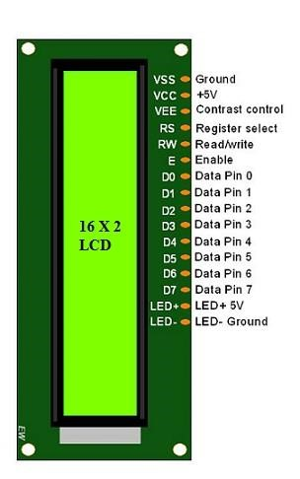

Fig 6.5.8 LCD Display

To interface an LCD (Liquid Crystal Display) with an IoT device, you typically use a microcontroller as an intermediary to control and display information on the LCD.

An LCD (Liquid Crystal Display) is a flat-panel display technology that uses liquid crystals to produce visual information. It's commonly used for displaying information in various electronic devices due to its low power consumption, thin profile, and ability to display characters, numbers, and simple graphics.

Pin Description:

VSS (Ground): Connect to the ground (GND) of your microcontroller.

VDD (Power): Connect to the power supply voltage (Vcc) of your microcontroller (usually +5V).

V0 (Contrast): This pin controls the contrast of the display. Connect it to a potentiometer to adjust the contrast.

RS (Register Select): This pin is used to select between data and command modes. Connect it to a digital pin on your microcontroller.

RW (Read/Write): Connect to ground (GND) if you are only writing to the LCD (most common case).

EN (Enable): This pin enables data read/write operations. Connect it to a digital pin on your microcontroller.

D0 to D7 (Data Lines): These pins carry data. Connect them to digital pins on your microcontroller. Usually, only D4 to D7 are used in 4-bit mode.

Here's a simplified connection guide for interfacing an LCD with an Arduino (or any other microcontroller):

* Connect VSS (Ground) to GND on Arduino.
* Connect VDD (Power) to +5V on Arduino.
* Connect V0 (Contrast) to a potentiometer's middle pin; connect the other two potentiometer pins to +5V and GND.
* Connect RS to a digital pin (e.g., D7) on Arduino.
* Connect RW to GND.
* Connect EN to a digital pin (e.g., D6) on Arduino.
* Connect D4 to D7 to digital pins (e.g., D5 to D2) on Arduino.
* Connect A (Anode) and K (Cathode) to control the backlight.

**Node MCU**

The NodeMCU stands as a versatile and cost-effective IoT platform built around the ESP8266 Wi-Fi module. With its onboard microcontroller and integrated Wi-Fi capabilities, this board offers an ideal solution for IoT and prototyping endeavors requiring wireless connectivity. At its core lies the ESP8266 chip, encompassing a powerful 32-bit Tensilica processor and GPIO pins, alongside inherent Wi-Fi functionalities. What makes the NodeMCU truly accessible is its compatibility with the Arduino IDE, opening doors for a vast community of Arduino enthusiasts and developers to harness its potential. Additionally, it supports Lua-based programming through the NodeMCU firmware, providing alternative pathways for programming and customization. Its GPIO pins offer extensive flexibility, enabling digital and analog input/output, PWM, and other interfaces for hardware connectivity. Moreover, the NodeMCU's integration of a USB-TTL converter simplifies programming and interfacing through a USB interface, making it an accessible choice for a wide array of IoT projects, prototyping initiatives, and educational endeavors. Its affordability, ease of use, and strong community support contribute to its popularity among hobbyists, students, and IoT enthusiasts worldwide, powering applications spanning home automation, sensor networks, smart devices, and beyond.

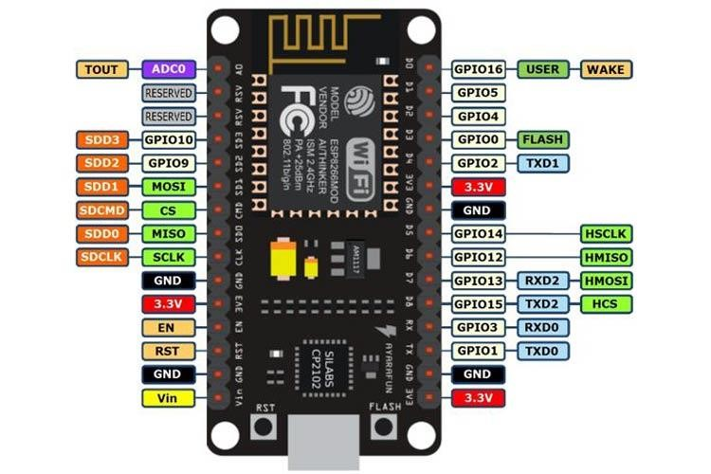

Figure 6.5.9 Node MCU

**GAS SENSOR**

The MQ-6 is a gas sensor module widely used for detecting the presence of various gases, including alcohol vapor in the air. Designed with a sensing element that responds to specific gas molecules, particularly those present in alcohol, it operates on the principle of chemical reaction. When exposed to alcohol vapor, the sensing element undergoes a change in resistance, which is then translated into an analog output signal proportional to the concentration of alcohol in the air. This analog signal is typically interfaced with a microcontroller for processing and analysis. The sensor requires a heating element to function effectively, ensuring that the sensing element operates at an optimal temperature for accurate detection. However, while the MQ-6 sensor is capable of detecting alcohol vapors, its precision, sensitivity, and response time may vary based on environmental conditions, humidity, and the specific alcohol being detected. Calibration and environmental considerations are crucial for reliable and accurate detection. Applications for the MQ-6 alcohol sensor include breathalyzers, safety systems to prevent drunk driving, monitoring alcohol levels in industrial environments, and various other applications concerned with detecting alcohol vapor in the atmosphere.

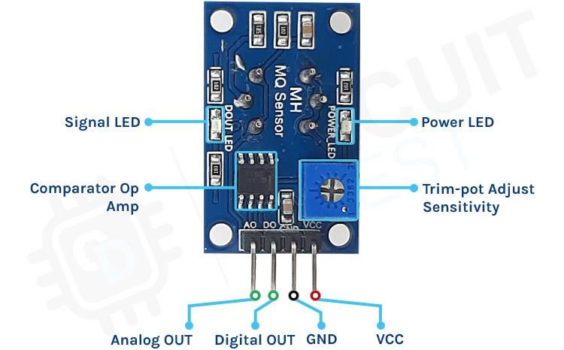

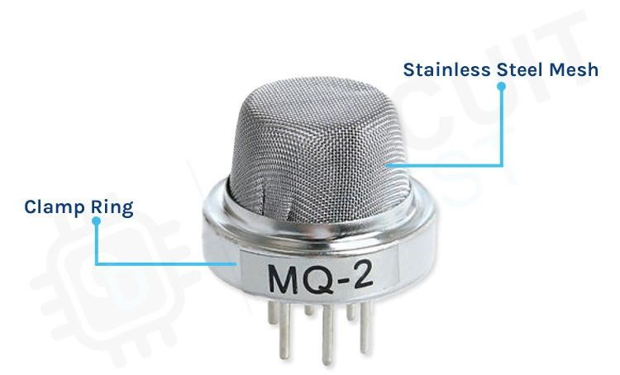

Figure 6.5.10 Gas sensor

**ADXL345**

The ADXL345, an advanced 3-axis digital accelerometer sensor developed by Analog Devices, stands as a fundamental component in motion-sensing applications. Its miniature form factor and MEMS-based technology enable precise measurement of both static and dynamic acceleration along the X, Y, and Z axes. With selectable acceleration ranges and high-resolution output, it provides accurate data representation, offering up to 13-bit resolution for finely detailed measurements. This sensor operates on low power, making it suitable for energy-efficient devices and systems. Its digital output, accessible through SPI or I2C interfaces, delivers real-time acceleration data, while integrated features like motion detection and tap sensing expand its usability in various applications. From consumer electronics to industrial machinery and health monitoring devices, the ADXL345's adaptability and accuracy make it a preferred choice for motion detection, orientation tracking, and impact monitoring in a broad spectrum of industries and technological advancements.

Specifications:

* Voltage: 3.3 V/ 5V.
* Interface Type: I²C, SPI.
* Sensing Range: ±2g, ±4g, ±8g, ±16g.
* Sensitivity:
* X: 28.6 LSB/g, Y: 31.2 LSB/g, Z: 34.5 LSB/g.

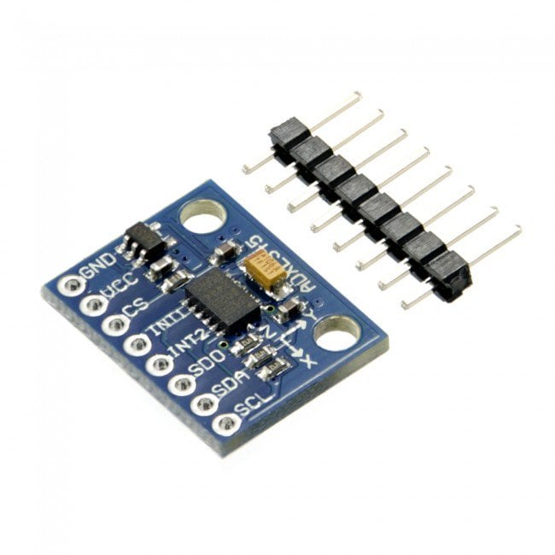

Figure 6.5.11 ADXL345

**RELAY**

A relay module is an electromechanical switch device that operates as a remote-controlled switch. It's designed to control high-power circuits or devices using low-power control signals, typically from a microcontroller or a digital sensor. The primary purpose of a relay module is to isolate and protect the controlling circuitry from the high voltages or currents present in the controlled circuit.

An electromechanical relay typically comprises several components:

* Electromagnet: Activated by an electrical current, it generates a magnetic field, allowing the relay to switch contacts.
* Mechanically Movable Contact: This movable part bridges connections based on the relay's status.
* Switching Points: The points where contacts connect or disconnect to alter the circuit state.
* Spring: Provides the force to move the contacts back to their default state when the electromagnet is deactivated.

Terminal Descriptions:

* COM (Common Pin): The central terminal acts as the central point for connections.
* NO (Normally Open): When the relay is idle, there's no connection between COM and NO. Activating the relay closes this circuit, providing power to the load.
* NC (Normally Closed): In its default state, there's a connection between COM and NC. When the relay is triggered, this circuit opens, interrupting power to the load.

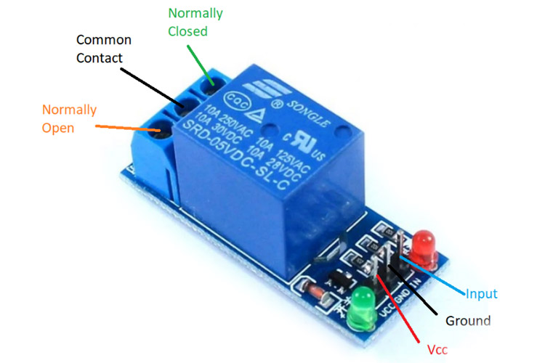

Figure 6.5.12 Relay

Specification:

* Rated through-current: 10A -5A
* Control signal: TTL level
* Voltage : 250VAC/30VDC
* Current : 10A

**POWER SUPPLY MODULE**

A power supply module is an electronic device or circuit that converts an input voltage or current into a stable, regulated output suitable for powering electronic devices or circuits. These modules are designed to provide a consistent and reliable power source, often for various electronic applications where a specific voltage or current is required.

three voltages of 3.3,5,12v.

Power Supply Specification:

* I/p voltage: 12v
* O/p voltage: +3.3v, +5v, +12v
* Max load: 0.5amp
* Frequency: 16MHz

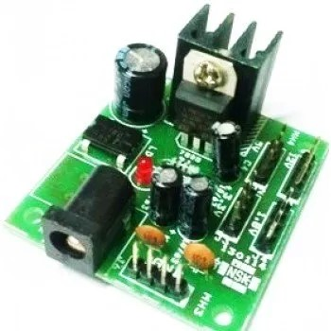

Fig 6.5.13 Power Supply Module

**6.6 IMPLEMENTATION**

The implementation of a driver alertness system involves integrating various technologies to continuously monitor the driver's condition and provide timely alerts. Here's a high-level overview of the implementation process:

* Sensor Integration:
  + Integrate sensors such as cameras, infrared sensors and facial recognition technology to monitor the driver's facial expressions, eye movements, and head position.
  + Utilize these sensors to detect signs of drowsiness, including eye closure or unusual facial expressions.
* Data Acquisition:
  + Develop a data acquisition system to capture real-time information from the integrated sensors.
  + Implement algorithms to process the data and extract relevant features indicative of driver alertness.
* Alerting Mechanism:
  + Design an alerting mechanism that provides timely feedback to the driver.
  + Alerts can include visual cues on a dashboard, auditory signals, etc.
* Machine Learning:
  + Explore machine learning techniques to enhance the system's ability to adapt and improve over time.
  + Train algorithms using labeled datasets to recognize patterns associated with drowsiness.
* Integration with Vehicle Systems:
  + Integrate the driver alertness system with the vehicle's central processing unit (CPU) or onboard computer.
  + Ensure compatibility with the vehicle's existing safety systems.
* Real-time Processing:
  + Implement real-time processing of sensor data to provide instantaneous alerts.
  + Minimize latency to ensure timely intervention in case of detected drowsiness.
* User Interface:
  + Display alerts, system status and relevant information on a dashboard or screen within the vehicle.
* Testing and Validation:
  + Conduct rigorous testing in simulated and real-world driving conditions.
  + Validate the system's effectiveness in accurately detecting drowsiness and providing timely alerts.
* Compliance and Certification:
  + Ensure compliance with safety standards and regulations related to automotive systems.
* Continuous Improvement:
  + Establish mechanisms for continuous improvement through software updates and enhancements.
  + Gather feedback from users and monitor system performance to address any identified issues.
* Privacy and Security Measures:
* Implement measures to safeguard driver privacy, such as anonymizing data and securing communication channels.
* Address security concerns to prevent unauthorized access to the system.

The successful implementation of a driver alertness system requires a multidisciplinary approach, involving expertise in sensor technology, data processing, human-machine interaction, and automotive safety. Regular updates and improvements based on real-world usage and technological advancements contribute to the system's ongoing effectiveness.

**6.7 HARDWARE IMPLEMETATION**

Arduino:

The Arduino Mega is a powerful iteration within the Arduino microcontroller family, renowned for its extensive capabilities and expanded features compared to its counterparts. Sporting a larger form factor and a more abundant array of input/output pins, the Mega boasts 54 digital input/output pins (of which 15 can be used for PWM output) and 16 analog inputs, offering ample connectivity options for various sensors, actuators, and other electronic modules simultaneously. Its enhanced memory capacity allows for more complex programs and larger data handling, making it ideal for projects demanding a higher degree of computational power or requiring multiple sensors and devices to be integrated seamlessly.

Buzzer:

An active buzzer is an electronic component that generates sound when it receives an electrical signal. Unlike a passive buzzer, which requires an external signal oscillating at an audible frequency to produce sound, an active buzzer has an internal oscillator circuit that produces the necessary oscillation, hence, it's "active."

PC with OpenCV:

OpenCV, short for Open-Source Computer Vision Library, is a powerful open-source computer vision and machine learning software library. It provides a wide array of tools and functions for real-time computer vision applications, image and video analysis, object detection and recognition, machine learning algorithms, and more. OpenCV is highly versatile and supports various programming languages like C++, Python, and Java, making it accessible to a broad community of developers and researchers. Its robustness and ease of use have made it a cornerstone in fields like robotics, augmented reality, facial recognition, and medical image processing, empowering developers to create innovative applications and solutions in the realm of computer vision.

USB:

The Arduino Uno can be powered via the USB connection, drawing power from a connected computer or USB power source. An alternative power input, allowing the board to be powered by an external DC power source (typically 7-12V). The board has a built-in voltage regulator that regulates this input to 5V, which powers the board.

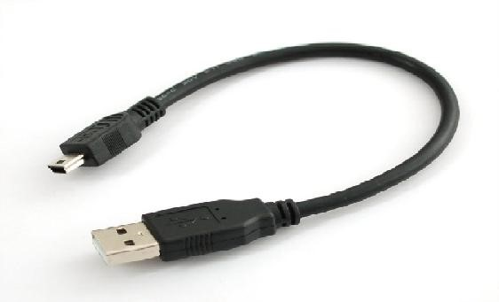

Figure 6.7.1 USB cable

UART:

UART (Universal Asynchronous Receiver-Transmitter) is a communication protocol widely used in IoT (Internet of Things) devices for serial communication between microcontrollers, sensors, and other peripheral devices. It allows for the transmission of data between devices using two wires: one for transmitting data (TX) and one for receiving data (RX).

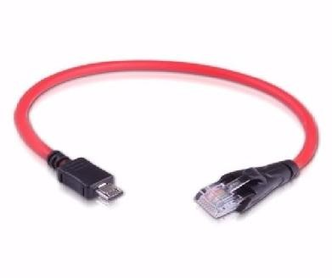

Figure 6.7.2 UART Cable

Alcohol sensor:

The MQ-6 is a gas sensor module widely used for detecting the presence of various gases, including alcohol vapor in the air. Designed with a sensing element that responds to specific gas molecules, particularly those present in alcohol, it operates on the principle of chemical reaction. When exposed to alcohol vapor, the sensing element undergoes a change in resistance, which is then translated into an analog output signal proportional to the concentration of alcohol in the air. This analog signal is typically interfaced with a microcontroller for processing and analysis. The sensor requires a heating element to function effectively, ensuring that the sensing element operates at an optimal temperature for accurate detection. However, while the MQ-6 sensor is capable of detecting alcohol vapors, its precision, sensitivity, and response time may vary based on environmental conditions, humidity, and the specific alcohol being detected.

Phone detector:

Phone detector is a device or system designed to identify the presence or activity of mobile phones within a certain vicinity.it detect the signal with in the range of 0.9to 3 ghz

Micro electro mechanical system devices (MEMS):

Micro Electro Mechanical System (MEMS) devices are miniaturized electromechanical systems that integrate mechanical elements, sensors, actuators, and electronics on a microscopic scale. These devices are fabricated using microfabrication techniques, allowing for the creation of tiny components with dimensions ranging from micrometers to millimeters.

MEMS devices encompass a wide range of applications across various industries due to their small size, low power consumption, and ability to perform a multitude of functions.

**6.8 SOFTWARE IMPLEMENTATION**

Python:

Python is like a friendly language for programming. It's not only easy to learn but also really flexible. You can use it for both small and big projects, and it's kind of fun too! Writing code in Python usually takes less time compared to other languages, which makes it faster for developers to create programs. The way Python is set up makes it easy for programmers to write code using fewer lines compared to languages like Java or C++. It was created back in 1991 by a developer named Guido Van Rossum, and it's become super popular because it's user-friendly and enjoyable to work with. Lots of big companies use Python because it supports different ways of writing code. You can do things step by step (that's called imperative programming), focus on objects and how they interact (that's object-oriented), and even do functional programming, which is like building code using small, reusable parts.

OpenCV:

OpenCV is like a toolkit that helps computers "see" and understand the world around them. It's a bunch of tools and functions created to help computers look at images or videos and figure out what's going on. Originally made by Intel, OpenCV is now free for anyone to use. It's like having a big box of tools for computers that want to understand pictures or videos in real time. You can use it on different types of computers because it works on all kinds of systems. One of the cool things about OpenCV is that it works well with other really smart programs that help computers learn stuff, like TensorFlow, Torch/PyTorch, and Caffe. This makes it even better at understanding and recognizing things in images or videos.

Qt editor:

Qt Creator is an integrated development environment (IDE) designed specifically for developing applications using the Qt application framework. It provides a user-friendly interface and a range of features to streamline the creation of software with Qt.

Xming with Putty:

Xming is an X Window System server for Windows operating systems. The X Window System is a framework that provides a graphical user interface and allows applications to display windows, graphics, and user interfaces on a computer. Putty, on the other hand, is a popular terminal emulator primarily used to connect to remote systems securely via SSH, Telnet, or other protocols. When used together, Xming and Putty create a setup where you can remotely access a Linux or Unix-based system (which uses the X Window System for its graphical interface) from a Windows machine.

Embedded C:

Embedded C is a special version of the C programming language made specifically for small computers, like those inside everyday devices or machines. Think of it as a tweaked or customized form of regular C, designed to work well with these tiny computer systems.

The reason we have Embedded C is that these small computers often have different features or ways of working compared to regular computers. So, Embedded C includes some extra bits and pieces to help programmers talk to these tiny computers more easily. For example, it helps handle special math types, manage different memory areas, and deal with basic tasks like getting input and showing output.

Twilio:

Twilio is a cloud-based platform that provides a set of tools and APIs (Application Programming Interfaces) for developers to build communication solutions within their applications. It allows developers to integrate features like voice calling, text messaging (SMS), video calls, and more into their software and websites using simple code.

With Twilio, developers can easily incorporate communication functionalities, enabling their applications to send and receive messages, make or receive phone calls, and manage various communication channels. The platform simplifies the process of adding these capabilities, offering scalability and flexibility to create custom communication experiences tailored to specific needs.

**CHAPTER-7**

**TIMELINE FOR EXECUTION OF PROJECT**

**(GANTT CHART)**

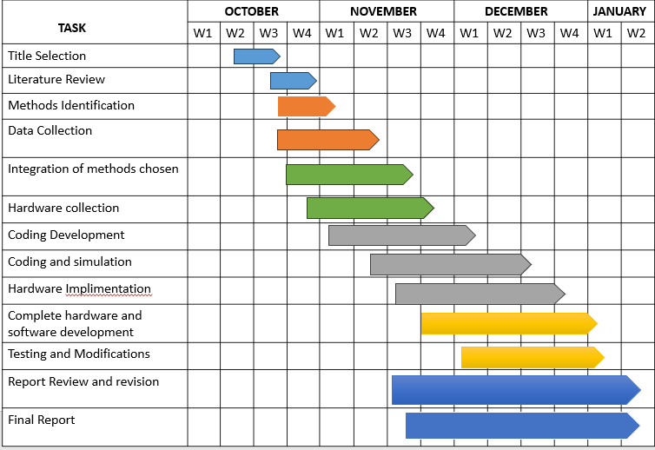

Table 7.1 Gantt Chart

**CHAPTER-8**

**OUTCOMES**

The implementation of the driver alertness system is poised to bring about transformative outcomes in the realm of road safety and driving experiences. The foremost impact is expected in accident prevention, where the system's ability to significantly reduce incidents arising from drowsy driving or impaired alertness promises a safer road environment for drivers, passengers, and pedestrians alike. The real-time monitoring and alerting capabilities ensure timely intervention, providing drivers with immediate warnings and opportunities to address signs of drowsiness promptly. This proactive approach not only prevents potential accidents but also fosters a heightened sense of awareness among drivers about their own alertness levels and the associated risks. The system's customization features further enhance the user experience by adapting to individual driver preferences and variations in driving behavior. In commercial settings, the implementation of such systems is anticipated to lead to enhanced fleet safety records, translating to reduced operational costs, improved corporate reputation, and an overall increase in fleet efficiency. As these outcomes materialize, the driver alertness system becomes a pivotal tool in reshaping road safety practices and cultivating a culture of responsible and vigilant driving.

* Accurate Real-time Alertness Monitoring:

Successful development of a system capable of accurately monitoring and assessing driver alertness in real-time.

Utilization of various sensors and technologies to capture diverse aspects of alertness.

* Timely Fatigue Identification:

Efficient identification of early signs of driver fatigue or drowsiness.

Implementation of algorithms that can provide timely alerts to prevent potential accidents.

* Improved Driver Safety Measures:

Implementation of the alertness detection system contributing to enhanced overall driver safety.

Reduction in the number of accidents related to driver fatigue.

* Reduced Accidents and Improved Road Safety:

A quantifiable reduction in accidents attributed to driver fatigue.

Positive impact on overall road safety statistics in the regions where the system is implemented.

* Cost-Benefit Analysis:

Conducting a thorough cost-benefit analysis to evaluate the economic viability of the system.

Consideration of the financial implications for both individual users and organizations implementing the technology.

* Integration with Existing Vehicle Systems:

Seamless integration with existing vehicle systems, ensuring compatibility with a wide range of vehicles.

Collaboration with automotive manufacturers for standardized integration protocols.

**CHAPTER-9**

**RESULTS AND DISCUSSIONS**

An original driver readiness discovery framework has been conceptualized, zeroing in on constant weakness location. This creative methodology effectively recognizes markers, for example, eye flicker examples and sluggishness. The strategy includes separating data about the eyes' situations through complex picture handling calculations, giving a painless method for identifying sleepiness without bringing on any distress or obstruction. The framework utilizes a face acknowledgment calculation, which, when applied, shows a compelling estimation of the squint rate.

Fundamentally, the proposed calculation shows powerful execution in identifying eyes under different lighting conditions, working great at both medium and high enlightenment levels. Besides, its viability isn't dependent upon elements like orientation or age, exhibiting a flexible application. Nonetheless, ideal outcomes are accomplished when the camera is situated as obviously as could be expected. To counter the possible effect of deficient light, a night vision camera has been integrated into the framework, guaranteeing predictable and exact outcomes paying little heed to brilliance levels. The execution of a ringer marker goes about as a ready component, adding to safe driving practices.

With regards to contemporary difficulties, tipsy driving mishaps have arisen as an unmistakable concern. This paper presents a complex arrangement that can be consistently incorporated into vehicles through a multi-stage testing approach. The framework offers progressed highlights to resolve the issues related with liquor related street mishaps, introducing a huge commitment to future street wellbeing. Utilizing Web of Things (IoT) innovation, the undertaking stresses equipment programming for an IoT gadget intended to work as both a liquor indicator and a preventive gadget.

Moreover, the examination digs into a framework pointed toward identifying hand-held PDA utilization while driving. A ring marker is used as a sensor for distinguishing this way of behaving. The framework's result can either give an admonition to divert the driver's consideration only to the vehicle and the street or communicate a notice to a vehicle organization, possibly setting off a ringer. The fuse of liquor sensors improves the framework's usefulness, empowering the discovery of liquor utilization up to pre-set rate edges. This complete methodology adds to the improvement of an innovatively progressed and comprehensive answer for upgrading street wellbeing.

**CHAPTER-10**

**CONCLUSION**

A spearheading driver sharpness identification framework has been advanced, based on continuous exhaustion location. This inventive methodology adroitly recognizes indications of eye flickering and sluggishness. The technique includes the usage of picture handling calculations to gain data about the eyes' situation, offering a harmless means to identify sluggishness without causing bother or obstruction. Moreover, a face acknowledgment calculation has been utilized, yielding a solid estimation of the flicker rate.

Essentially, the proposed calculation shows adaptability, successfully recognizing eyes under differing light levels and autonomous of orientation and age. Be that as it may, ideal discovery execution is accomplished when the camera is situated obviously. To counter the expected effect of unfortunate recognition in low-light circumstances, a night vision camera has been coordinated, guaranteeing unrivaled outcomes unaffected by splendor levels. The framework consolidates a signal pointer to caution the driver, adding to upgraded street security.

Resolving the major problem of inebriated driving mishaps, this paper presents a high-level arrangement that can be flawlessly incorporated into vehicles through a multi-stage testing approach. This inventive framework holds significant commitment for moderating mishaps originating from liquor debilitated driving. Its potential effect is highlighted by its arrangement with the Web of Things (IoT), promising future executions. The task stresses equipment programming for an IoT gadget intended to work as both a liquor locator and a preventive gadget.

Besides, the exploration stretches out to a framework focusing on the recognition of hand-held phone utilization while driving. Utilizing a ring pointer as a sensor for recognizing this way of behaving, the framework's result can give an admonition, diverting the driver's consideration regarding the vehicle and the street. On the other hand, it might communicate an admonition to a vehicle organization or initiate a signal. The joining of liquor sensors improves the framework's usefulness, empowering the identification of liquor utilization up to preset rate limits. This far reaching approach highlights the improvement of a mechanically progressed and all encompassing answer for lifting street wellbeing norms

**REFERENCES**

[1] Data from NCRB, Government of India, available at http://ncrb.nic.in/StatPublications/ADSI/ADSI2014/ADSI2014.asp

[2] "Internet of Things Global Standards Initiative". ITU. Retrieved 26 June 2015. - http://www.itu.int/en/ITU-T/gsi/iot/Pages/default.aspx

[3] Z. Xiaorong et al, ―The Drunk Driving Automatic Detection System Based on Internet of Things‖, International Journal of Control and Automation.

[4] J. Dai, J. Teng, X. Bai, Z. Shen, and D. Xuan. "Mobile phone based drunk driving detection." In 2010 4th International Conference on Pervasive Computing Technologies for Healthcare, pp. 1-8. IEEE, 2010

[5] A. R. Varma, S. V. Arote, C. Bharti, and K. Singh. "Accident prevention using eye blinking and head movement." IJCA Proceedings on Emerging Trends in Computer Science and Information Technology-2012 (ETCSIT2012) etcsit1001 4 (2012)

[6] V. Savania, H. Agravata and D. Patela , ―Alcohol Detection and Accident Prevention of Vehicle‖, International Journal of Innovative and Emerging Research in Engineering, Volume 2, Issue 3, 2015, pp 55-59

[7] http://en.wikipedia.org/wiki/Global_Positioning_System.

[8] http://www.dadss.org/breath-based-technology.

[9] http://www.dadss.org/touch-based-technology.

[10] S sahabiswas, S sourav, ―Drunken driving detection and prevention models using

Internet of things‖, Information Technology, Electronics and Mobile Communication Conference (IEMCON), 2016 IEEE 7th Annual, pp.1-16, IEEE,2016

[11] Open CV 2.4.11.0 documentation; Open CV Tutorials; objdetect module;Object Detection.

[12] Viola, Jones: Robust Real-time Object Detection, IJCV 2001.

[13] Open CV Computer Vision with Python; Tracking Faces with Haar Cascades

[14] S. Motorist, Driver Fatigue is an important cause of Road Crashes, Smart Motorist.

[15] Driver Fatigue and Road Accidents: A Literature Review and Position Paper

[16] Royal Society for the Prevention of Accidents, 2001.

[17] Road and Traffic Authority (RTA) Annual Report, Sidney, 2008.

[18] B. Praveenkumar, K Mahendrakan. "Prevention of Accident Due To Drowsy By Using Eye Blink." International Journal of Innovative

Research in Science, Engineering and Technology(IJIRSET)Volume 3, May 2014.

[19] Stan, Ovidiu, Liviu Miclea, and Ana Centea. "Eye-Gaze Tracking Method Driven by

Raspberry Pi Applicable in Automotive Traf¿c Safety. "Arti¿cial Intelligence,

Modelling and Simulation (AIMS), 2014 2nd International Conference on IEEE, 2014.

[20] Friedrichs, Fabian, and Bin Yang. "Camera-based drowsiness reference for driver state classi¿cation under real driving conditions." Intelligent Vehicles Symposium (IV), 2010,IEEE. IEEE, 2010.

[21] "Eye detection and recognition in the fatigue warning system." Intelligent Networks and Intelligent Systems (ICINIS), 2010 3rd International Conference on IEEE, 2010.

[22] Turan, Garima, and Sheifali Gupta. "Road Accidents Prevention system using

Driver‘s Drowsiness Detection." International Journal of Advanced Research in Computer Engineering and Technology (IJARCET).

[23] <https://arxiv.org/ftp/arxiv/papers/2303/2303.06310.pdf>

[24] <https://www.ijeat.org/wp-content/uploads/papers/v11i1/A31591011121.pdf>

[25] <https://www.ijraset.com/research-paper/driver-drowsiness-detection-using-ml>

[26] <https://www.ijeat.org/wp-content/uploads/papers/v11i1/A31591011121.pdf>

[27] <https://www.sciencedirect.com/science/article/abs/pii/S2542660523000288>

**APPENDIX-A**

**PSUEDOCODE**

PSUEDOCODE SOFTWARE PART:

Initialize Libraries and Models:

* Import necessary libraries (e.g., OpenCV, dlib).
* Load the Haarcascade for face detection.
* Load the pre-trained facial landmark predictor model from dlib.

Initialize Video Capture:

* Open a video stream or connect to a webcam.

Define Functions:

* Define a function for calculating the eye aspect ratio (EAR).
* Define a function for calculating the mouth aspect ratio (MAR).
* Define a function for detecting yawns based on mouth aspect ratio.

Main Loop:

* Start an infinite loop to continuously capture frames from the video stream.

Face Detection:

* Read the current frame.
* Convert the frame to grayscale for face detection.
* Use Haarcascade to detect faces in the frame.

Facial Landmarks Detection:

* For each detected face, use dlib to find facial landmarks (eye and mouth landmarks).

Eye Aspect Ratio (EAR) Calculation:

* Calculate the EAR for each eye using the detected landmarks.

Mouth Aspect Ratio (MAR) Calculation:

* Calculate the MAR using the detected mouth landmarks.
* Drowsiness Detection:
* Set a threshold for both EAR and MAR to classify the driver's state (e.g. closed eyes, yawn).
* If the EAR falls below a certain threshold, flag drowsiness.
* If the MAR exceeds a certain threshold, flag yawning.

Display and Alert:

* Display the current frame with annotations (e.g., landmarks, aspect ratio values).
* If drowsiness or yawning is detected, display an alert on the screen or trigger an alarm.

PSEUDO CODE HARDWARE PART:

Sensor Setup:

* Define pins and constants for the alcohol and accident sensors.
* Set threshold values for triggering alerts based on sensor readings.

Telegram Bot Setup:

* Define the Telegram Bot token and chat ID for sending messages.

Sensor Reading Functions:

* Implement functions to read values from the alcohol and accident sensors.

Telegram Message Sending Function:

* Implement a function to send messages to Telegram using the specified bot token, chat ID, and message.

Setup Function:

* Initialize serial communication for debugging.
* Set up the pins for the alcohol and accident sensors.

Main Loop:

* Continuously read sensor values in the loop.
* Check for high alcohol levels and accidents.
* If the conditions are met, send a corresponding message to Telegram.

Delay:

* Introduce a delay of 1000 milliseconds (1 second) before the next iteration of the loop.

**APPENDIX-B**

**SCREENSHOTS**

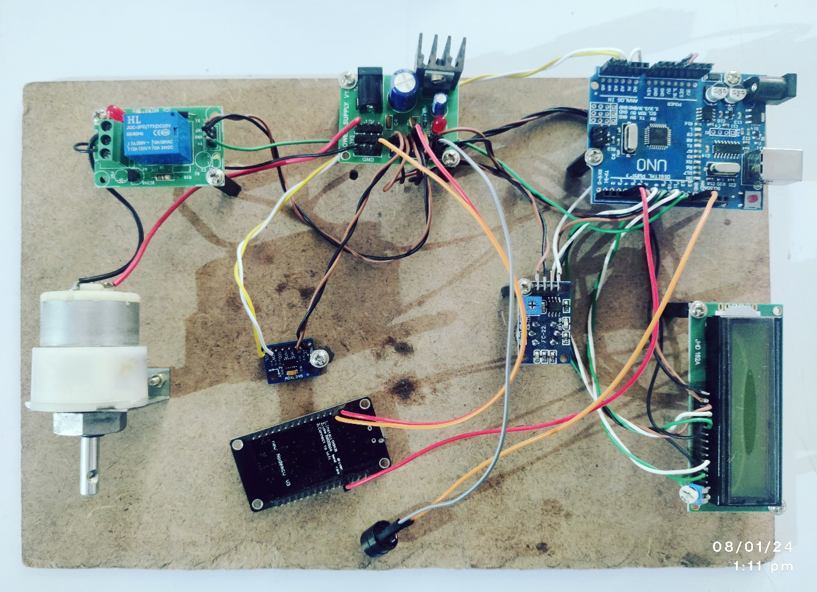 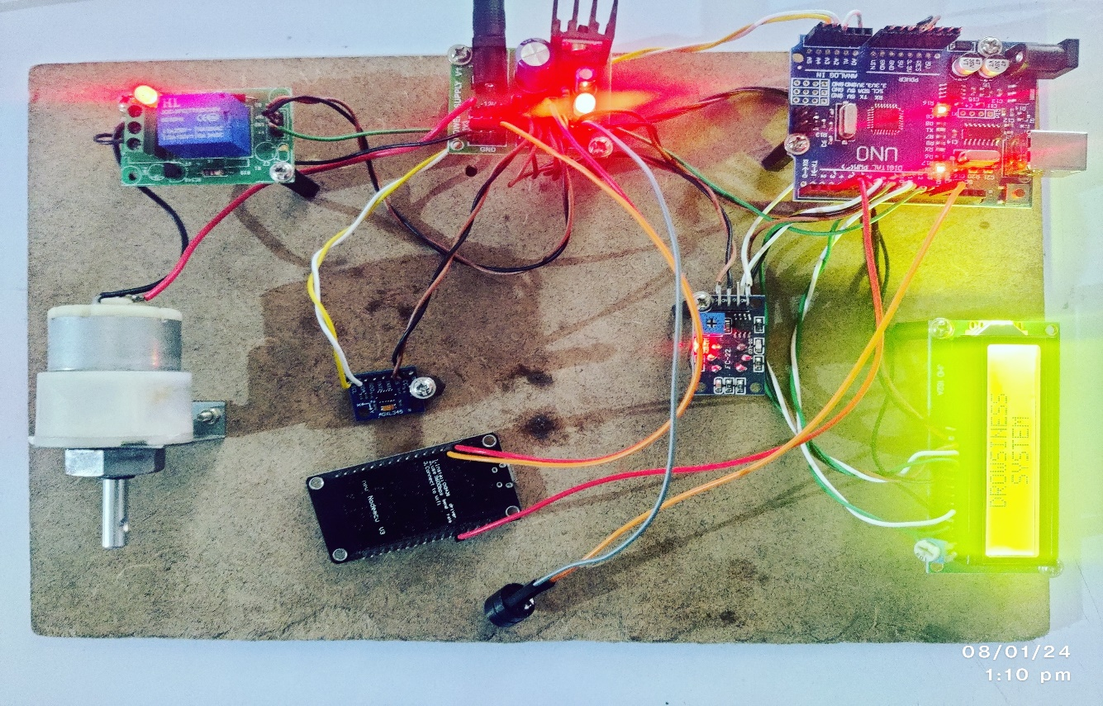

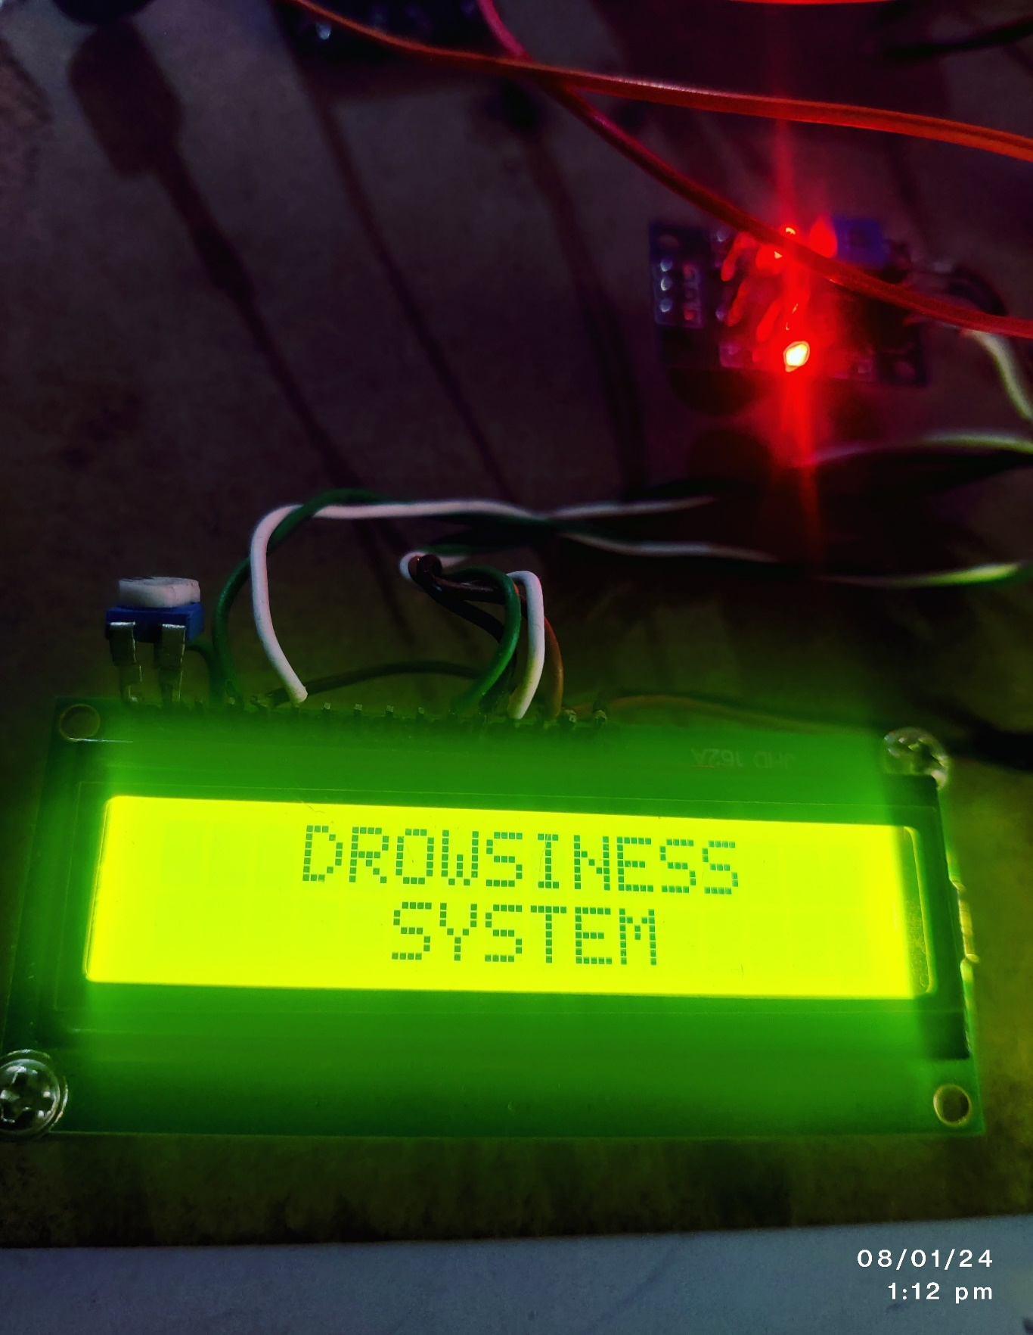

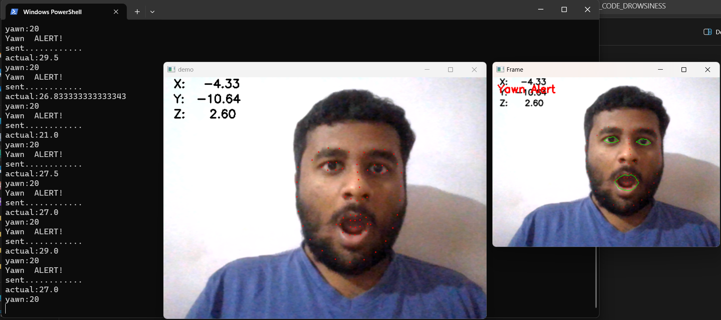

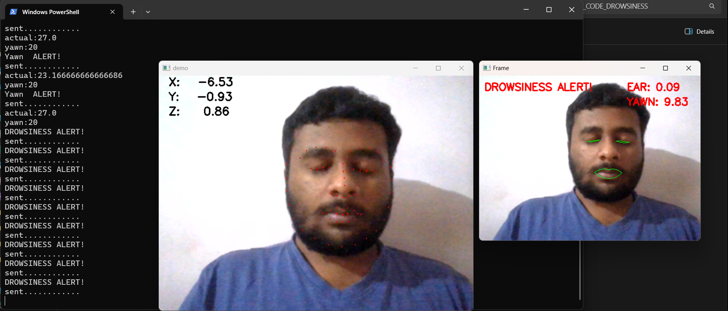

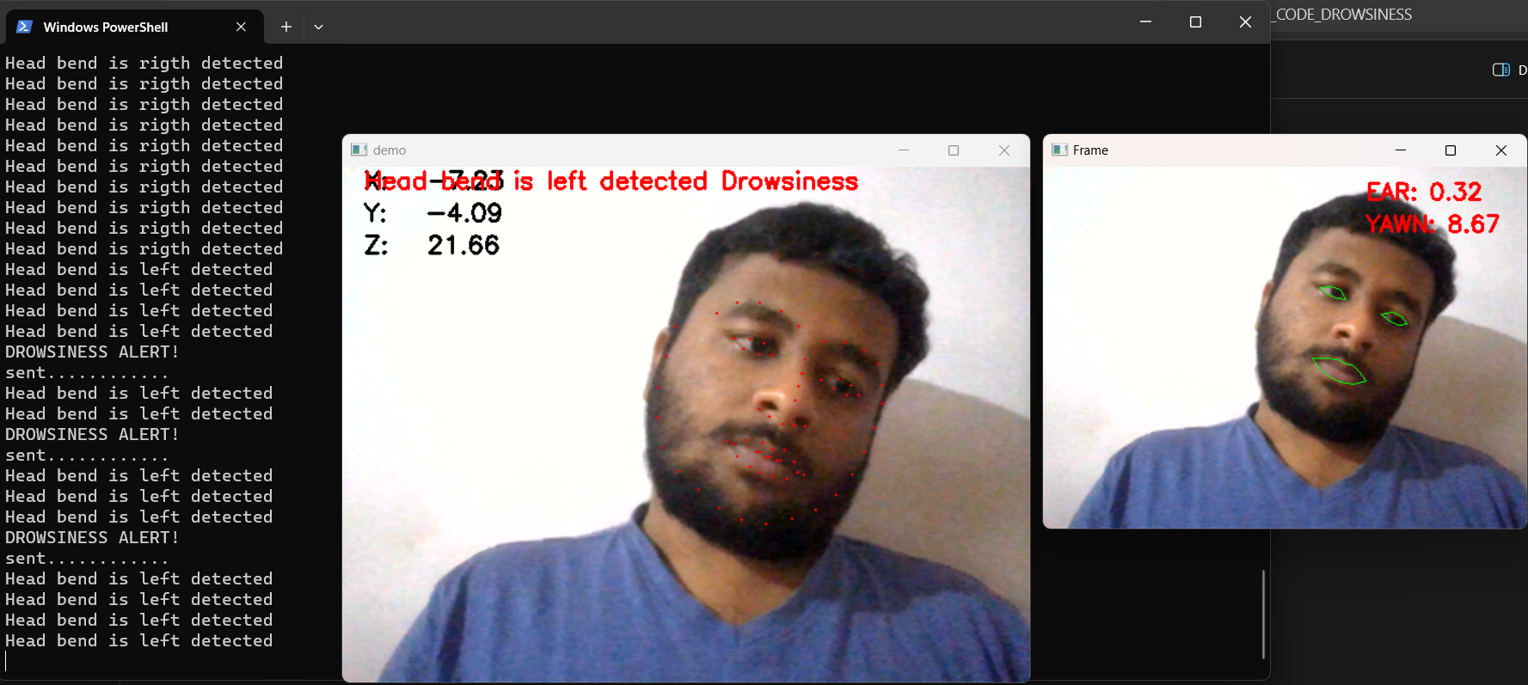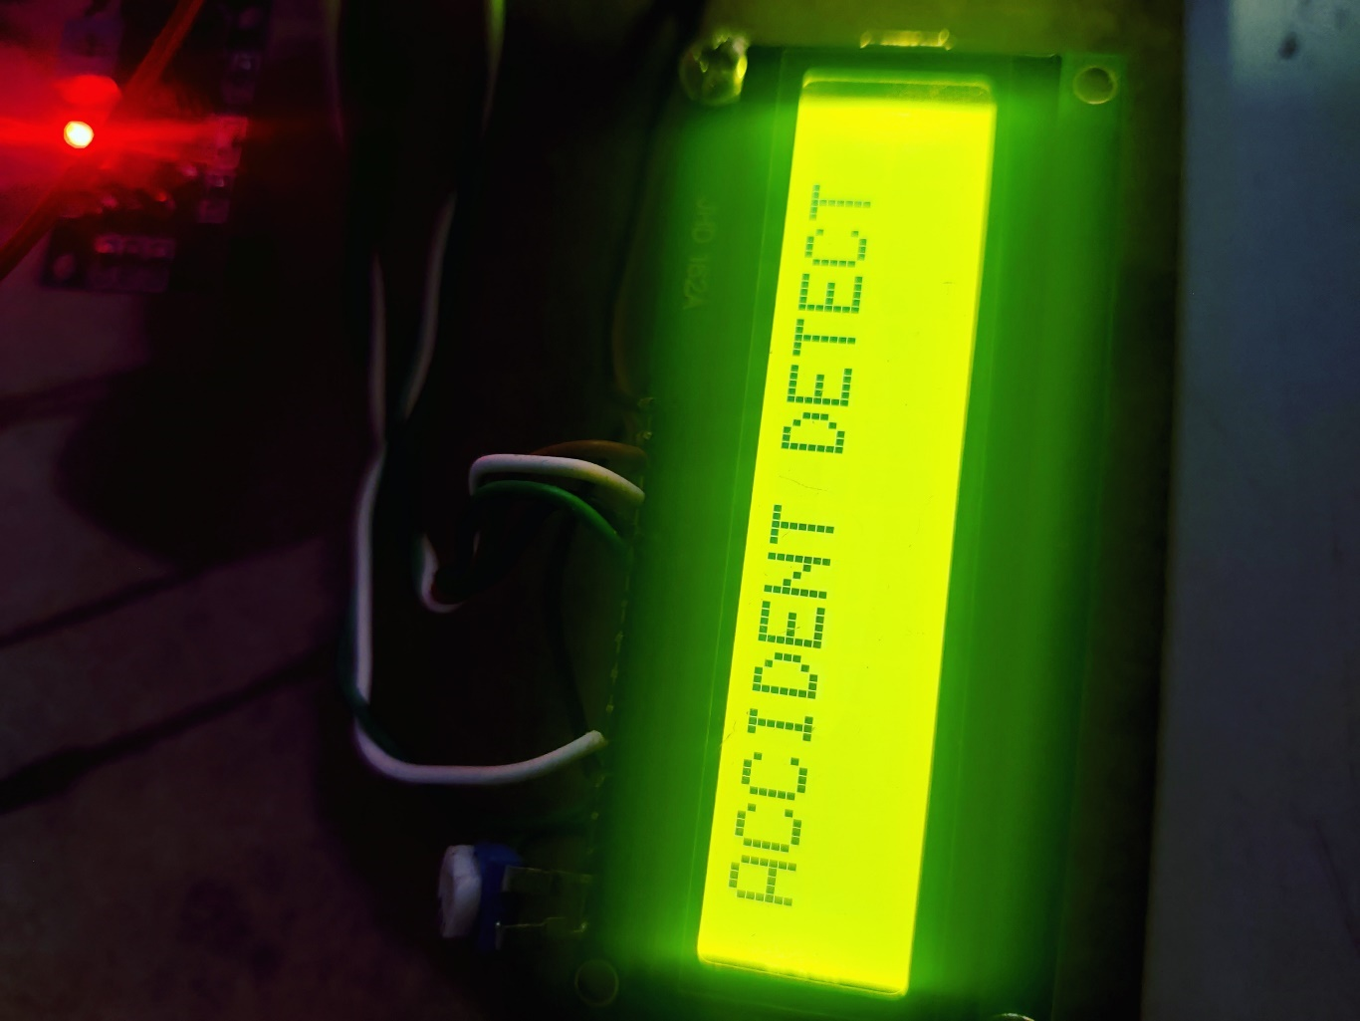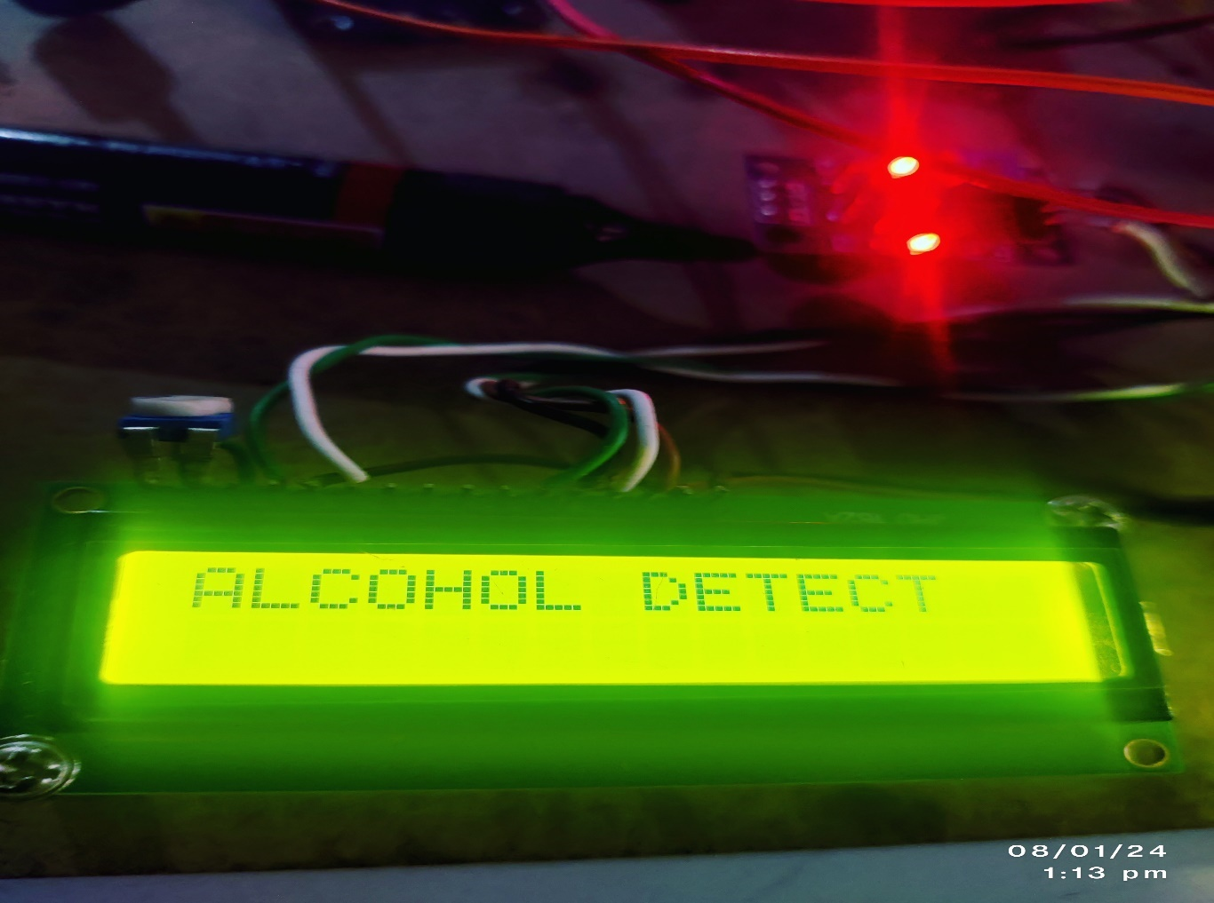

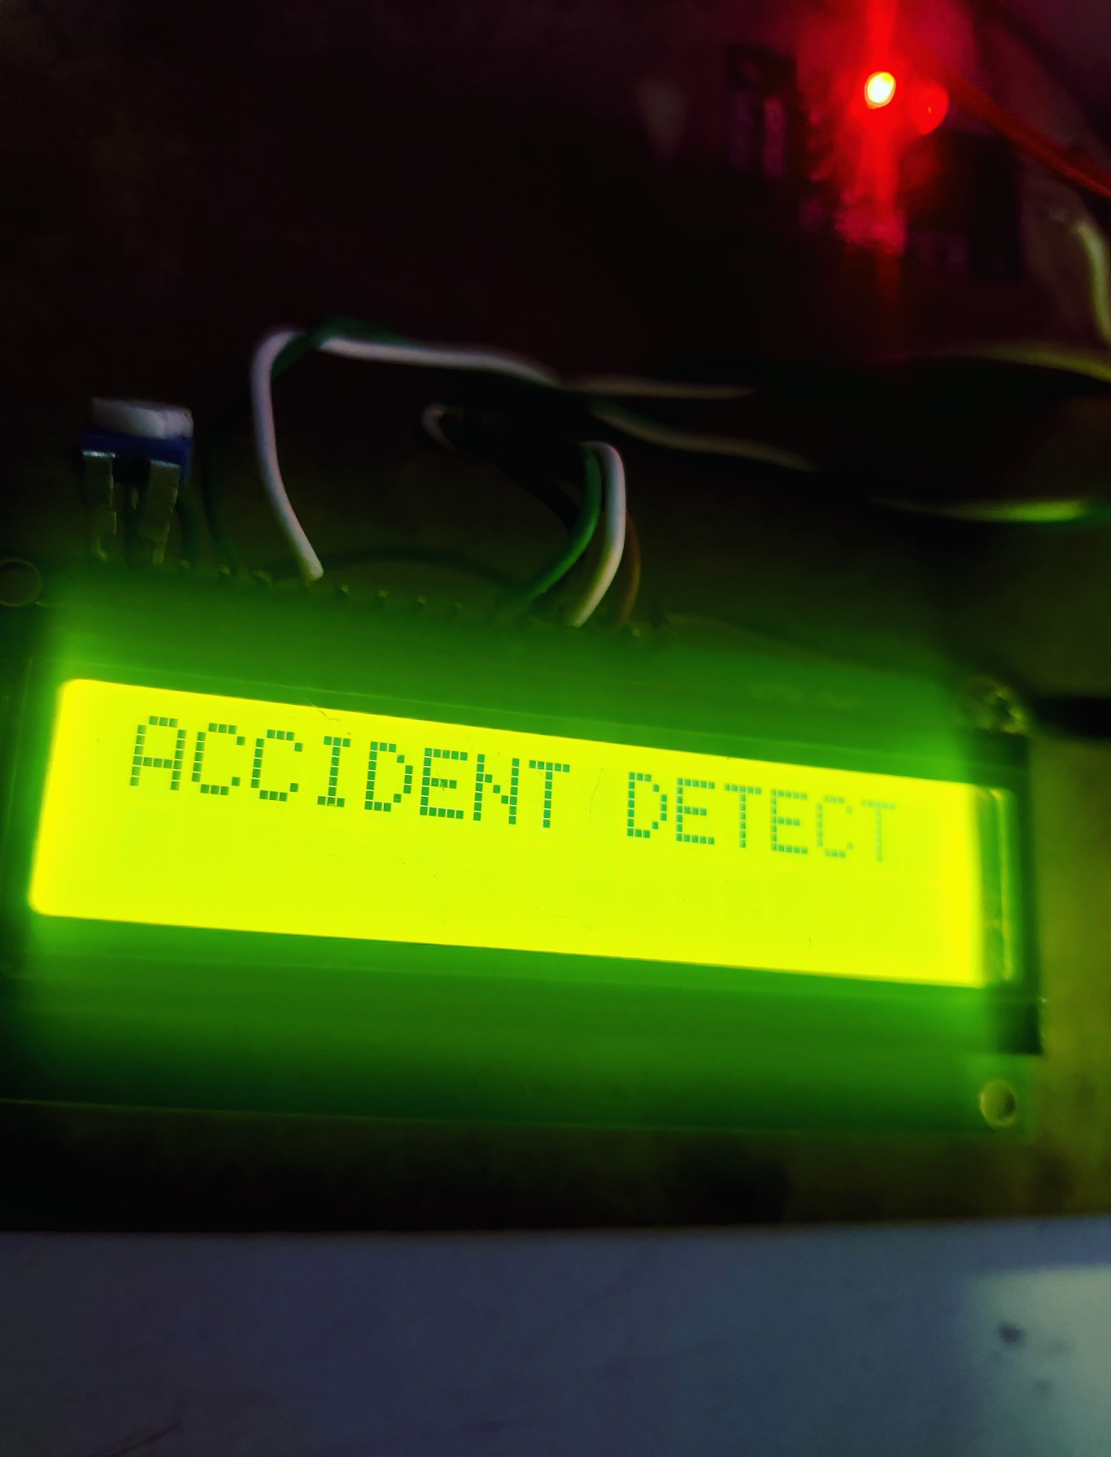

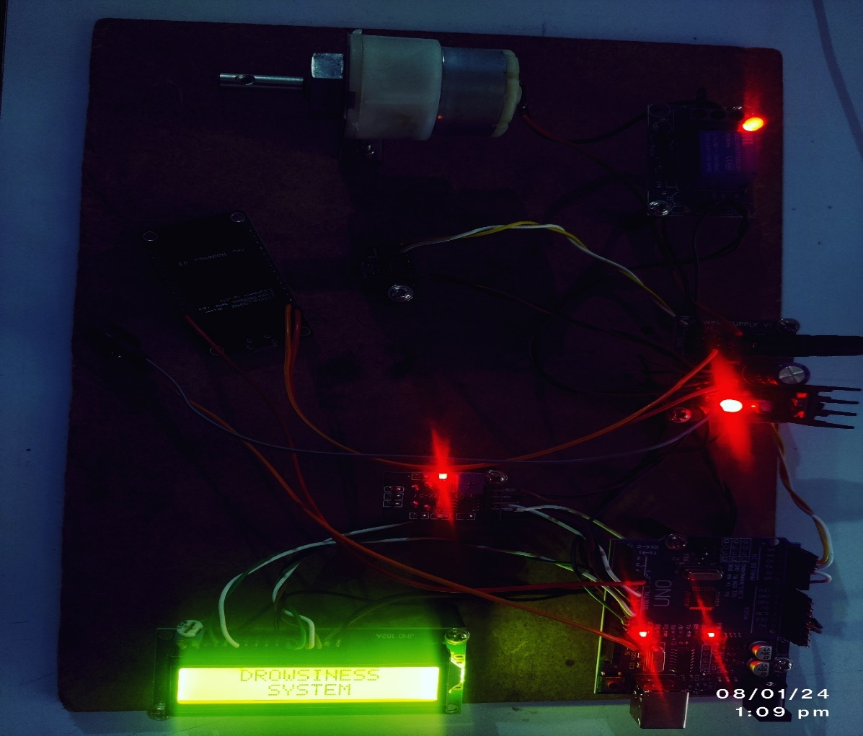

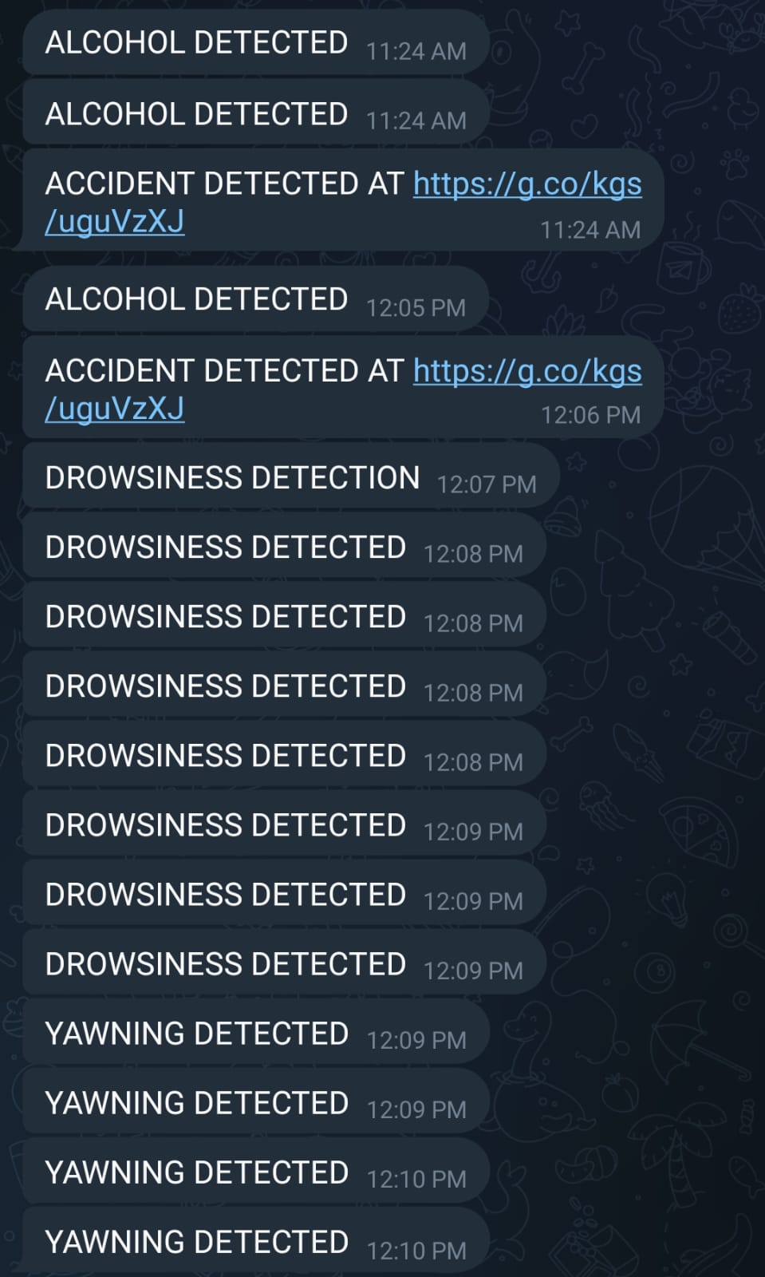



**APPENDIX-C**

**ENCLOSURES**

**1. Conference Paper Presented Certificates of all students.**

**2. Include certificate(s) of any Achievement/Award won in any project related event.**

**3. Similarity Index / Plagiarism Check report clearly showing the Percentage (%). No need of page-wise explanation.**

Acceptance Certificate:



Project Report:



Sustainable Development Goals:



This driver monitoring system actively contributes to multiple Sustainable Development Goals (SDGs). Primarily, it aligns with Goal 3 (Good Health and Well-being) by enhancing road safety. By detecting driver drowsiness or intoxication, it significantly reduces the risk of accidents and associated injuries, ultimately promoting better health outcomes. Furthermore, its implementation reflects Goal 9 (Industry, Innovation, and Infrastructure) by leveraging innovative technologies like Visual Studio, OpenCV and Emgu library to create safer transportation infrastructure. This directly ties into Goal 11 (Sustainable Cities and Communities) by fostering safer urban environments through the prevention of road accidents. Additionally, the system supports Goal 12 (Responsible Consumption and Production) by curbing resource wastage linked to accidents, thereby encouraging responsible resource utilization. Finally, in line with Goal 17 (Partnerships for the Goals), its development involves collaboration between software developers, technology experts and transportation authorities, emphasizing the significance of partnerships to achieve collective goals in promoting safer roads and communities.